TOPIC 1: RELATIONS

Normally relation deals with matching of elements from the first set called DOMAIN with the element of the second set called RANGE.

Relations

A relation "R" is the rule that connects or links the elements of one set with the elements of the other set.

Some examples of relations are listed below:

"Is a brother of "

"Is a sister of "

"Is a husband of "

"Is equal to "

"Is greater than "

"Is less than "

Normally relations between two sets are indicated by an arrow coming from one element of the first set going to the element of the other set.

Relations Between Two Sets

Find relations between two sets

The relation can be denoted as:

R = {(a, b): a is an element of the first set, b is an element of the second set}

Consider the following table

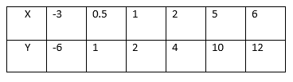

This is the relation which can be written as a set of ordered pairs {(-3, -6), (0.5, 1), (1, 2), (2, 4), (5, 10), (6, 12)}. The table shows that the relation satisfies the equation y=2x. The relation R defining the set of all ordered pairs (x, y) such that y = 2x can be written symbolically as:

R = {(x, y): y = 2X}.

Relations Between Members in a Set

Find relations between members in a set

Which of the following ordered pairs belong to the relation {(x, y): y>x}?

(1, 2), (2, 1), (-3, 4), (-3, -5), (2, 2), (-8, 0), (-8, -3).

Solution.

(1, 2), (-3, 4), (-8, 0), (8,-3).

Relations Pictorially

Demonstrate relations pictorially

For example the relation " is greater than " involving numbers 1,2,3,4,5 and 6 where 1,3 and 5 belong to set A and 2,4 and 6 belong to set B can be indicate as follows:-

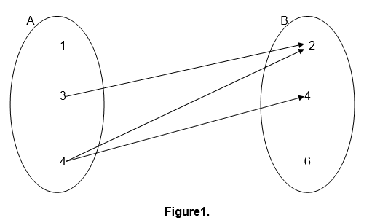

This kind of relation representation is referred to as pictorial representation.

Relations can also be defined in terms of ordered pairs (a,b) for which a is related to b and a is an element of set A while b is an element of set B.

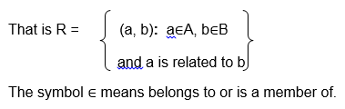

For example the relation " is a factor of " for numbers 2,3,5,6,7 and 10 where 2,3,5 and 6 belong to set A and 6,7 and 10 belong to set B can be illustrated as follows:-

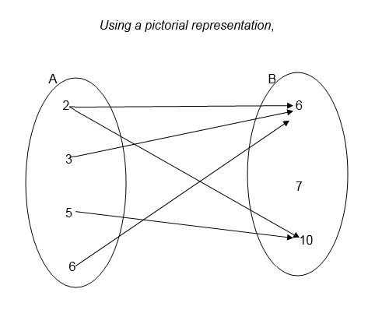

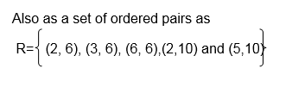

Example 1

<!-- [if !supportLists]-->1. Draw an arrow diagram to illustrate the relation which connects each element of set A with its square.

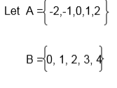

Solution

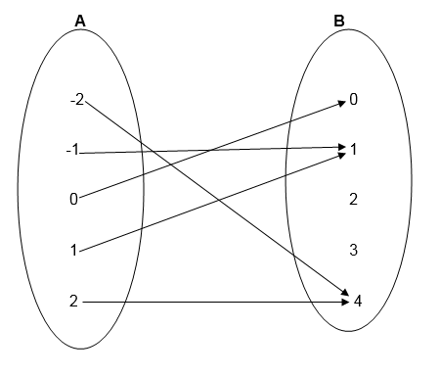

Example 2

Using the information given in example 1, write down the relation in set notation of ordered pairs. List the elements of ordered pairs.

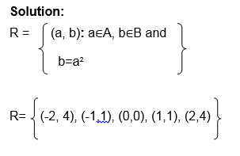

Example 3

As we,

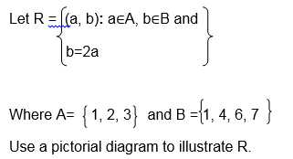

Solution;

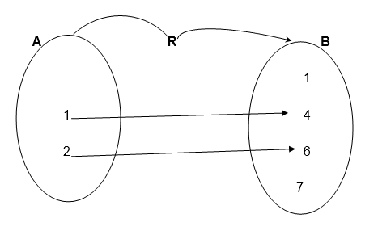

Example 4

Let X= {2, 3, 4 } and Y= {3 ,4, 5}

Draw an arrow diagram to illustrate the relation " is less than"

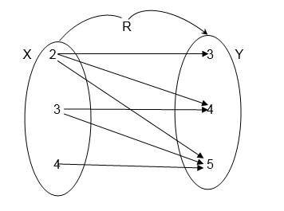

Exercise 1

Let P= {Tanzania, China, Burundi, Nigeria}

Draw a pictorial diagram between P and itself to show the relation

"Has a larger population than"

2. Let A = 9,10,14,12 and B = 2,5,7,9 Draw an arrow diagram between A and B to illustrate the relation " is a multiple of"

3.Let A = mass, Length, time and

B = {Centimeters, Seconds, Hours, Kilograms, Tones}

Use the set notation of ordered pairs to illustrate the relation "Can be measured in"

4. A group people contain the following; Paul Koko, Alice Juma, Paul Hassan and Musa Koko. Let F be the set of all first names, and S the set of all second names.

Draw an arrow diagram to show the connection between F and S

5. Let R={ (x, y): y=x+2}

Where x∈A and A ={ -1,0,1,2}

and y∈B, List all members of set B

Exercise 2

1. Let the relation be defined

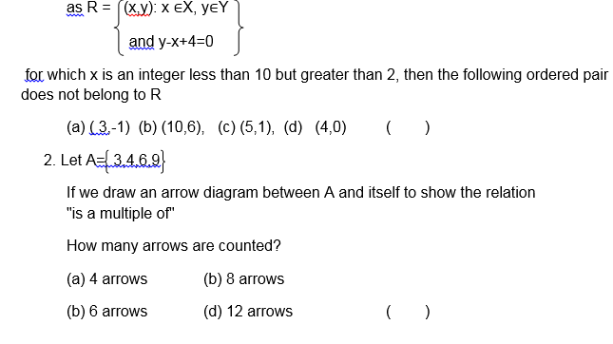

Consider the following pictorial diagram representing a relation R.

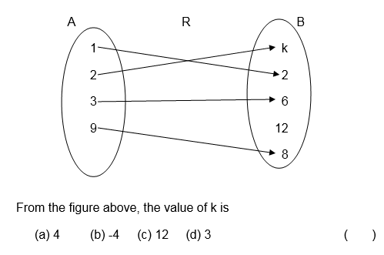

Let the relation R be defined as



A relation R on sets a and B where A = 1,2,3,4,5 and B = 7,8,9,10,11,12 is defined as " is a factor of "

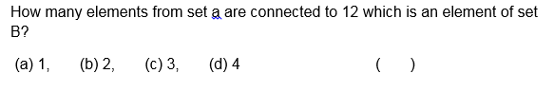

Graph of a Relation

A Graph of a Relation Represented by a Linear Inequality

Draw a graph of a relation represented by a linear inequality

Given a relation between two sets of numbers, a graph of the relation is obtained by plotting all the ordered pairs of numbers which occur in the relation

Consider the following relation

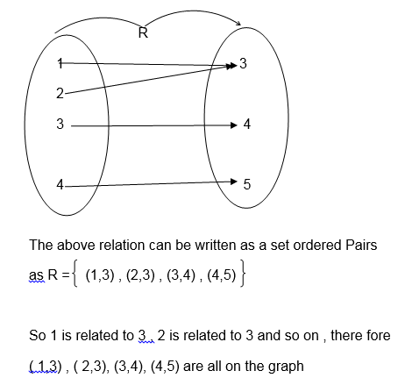

The graph of R is shown the following diagram( x-y plane).

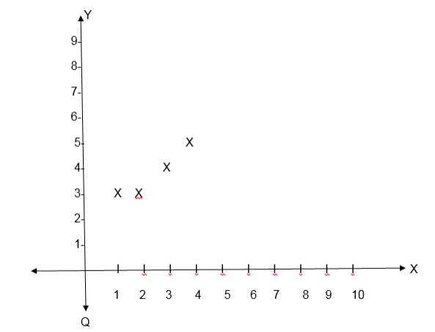

Example 5

Solved:

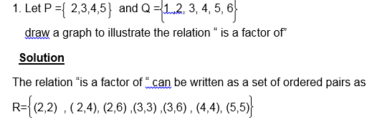

Note that some relations have graphs representing special figures like straight lines or curves.

Example 6

Draw the graph for the relation R= {(x, y): y = 2x +1} Where both x and y are real numbers.

Solution

The equation y = 2x +1 represents a straight line, this line passes throng uncountable points. To draw its graph we must have at least two points through which the line passes.

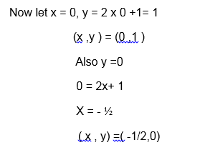

Graph;

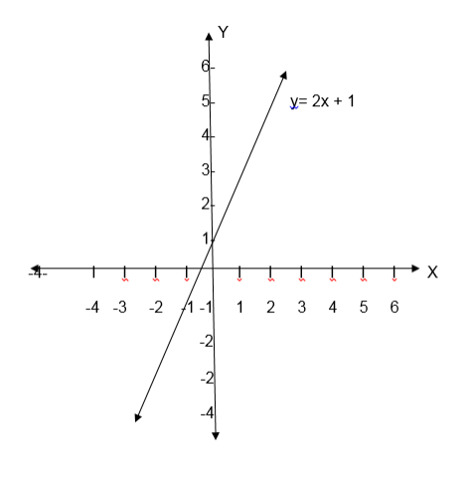

Example 7

Let A = {-2,-1,0, 1, 2 } and B ={0,1,2,3,4}

Let the relation R be y= x2, where x ∈A and y∈B. Draw the graph of R

Solution

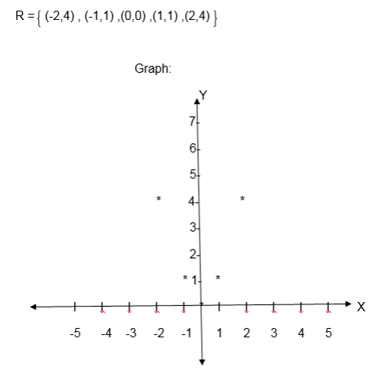

NB: When the relation is given by an equation such as y = f (x), the domain is the set containing x- values satisfying the equation and the range is the set of y-values satisfying the given equation.

Exercise 3

Test Yourself:

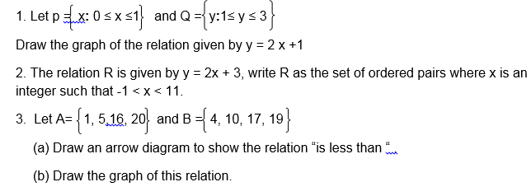

Quiz.

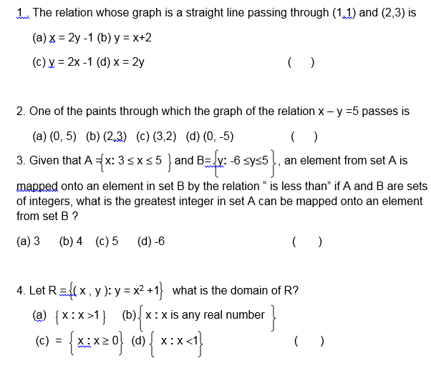

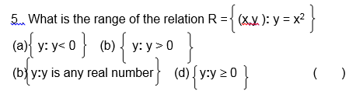

Domain and Range of a Relation

The Domain of Relation

State the domain of relation

Domain: The domain of a function is the set of all possible input values (often the "x" variable), which produce a valid output from a particular function. It is the set of all real numbers for which a function is mathematically defined.

The Range of a Relation

State the range of a relation

Range: The range is the set of all possible output values (usually the variable y, or sometimes expressed as f(x)), which result from using a particular function.

If R is the relation on two sets A and B such that set A is an independent set while B is the dependent set, then set A is the Domain while B is the Co-domain or Range.

Note that each member of set A must be mapped to at least one element of set B and each member of set B must be an image of at least one element in set A.

Consider the following relation

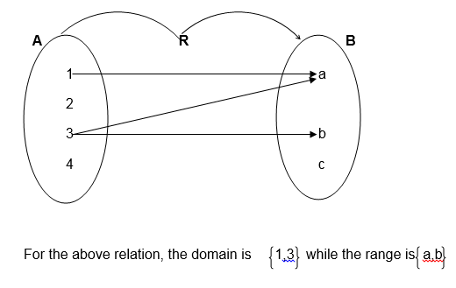

Example 8

Let P = 1,3,4,10 and Q = 0,4,8

Find the domain and range of the relation R:” is less than”

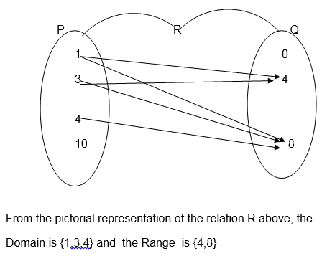

Example 9

As we,

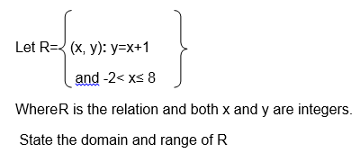

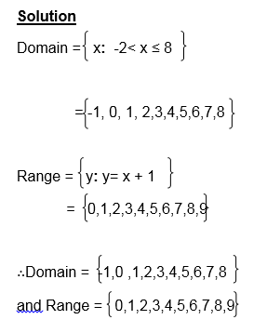

Exercise 4

1. Let A = { 3,5,7,9 } and B = {1,4,6,8 } , find the domain and range of the relation “is greater than on sets A and B

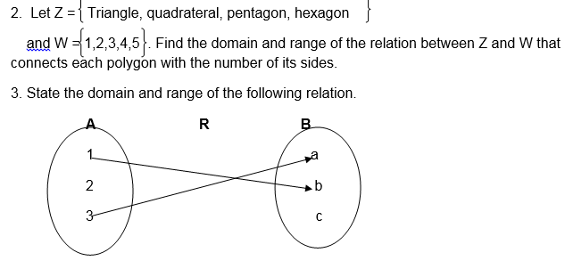

4. Let X ={3, 4, 5, 6} and

Y ={2, 4, 6, 8}

Draw the pictorial diagram to illustrate the relation “is less than or equal to‘ and state its domain and range

Inequalities:

The equations involving the signs < , ≤, > or ³ are called inequalities

Eg. x<3 x is less than 3

x>3 x is greater than 3

x≤ 2 x is less or equal to 2

x³ 2 x is greater or equal to 2

x > y x is greater or than y etc

Inequalities can be shown on a number line as in the following

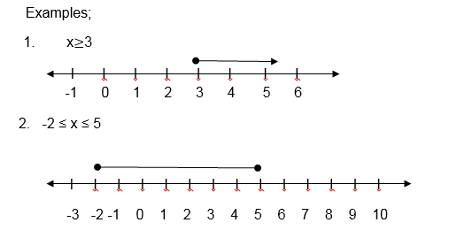

Inequalities involving two variables:

If the inequality involves two variables it is treated as an equation and its graph is drawn in such a way that a dotted line is used for > and < signs while normal lines are used for those involving ≤ and ≥.

The line drawn separates the x-y plane into two parts/regions

The region satisfying the given inequality is shaded and before shading it must be tested by choosing one point lying in any of the two regions,

Example 10

1. Draw the graph of the relation R = {(x, y): x>y}

Solution:

x>y is the line x =y but a dotted line is used.

Graph

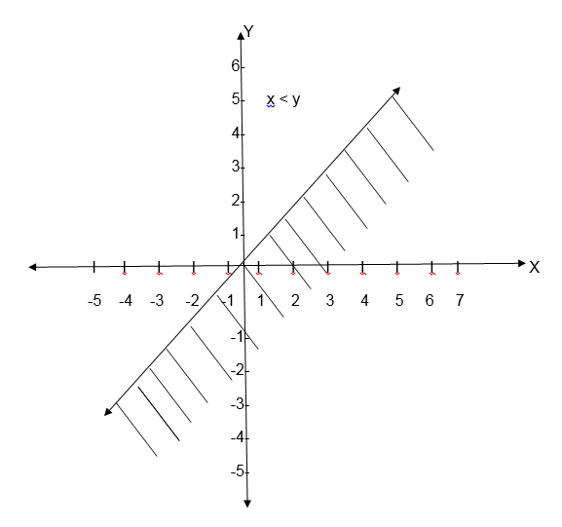

If you draw a graph of the relation R = {(x,y ) : x < y} , the same line is draw but shading is done on the upper part of the line.

Exercise 5

1. Draw the graph of the relation R = {(x,y ): x + y > 0}

2 .Draw the graph of the relation R = {( x ,y ) : x – y ³ -2}

3. Write down the inequality for the relation given by the following graph

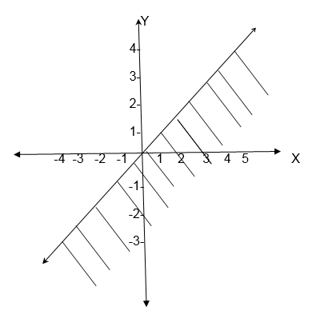

4. Draw a graph of the inequality for the relation x >-2 and shade the required region.

Domain and Range from the graph

Definition: Domain is the set of all x values that satisfy the given equation or inequality.

Similarly Range is the set of all y value satisfying the given equation or inequality

Example 11

1. Consider the following graph and state its domain and range.

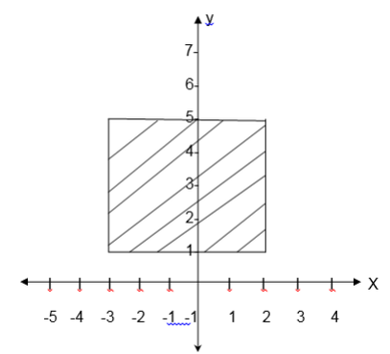

Solution

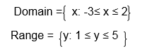

Example 12

State the domain and range of the relation whose graph is given below.

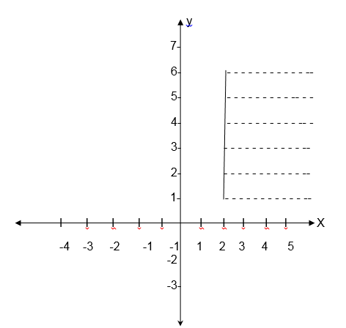

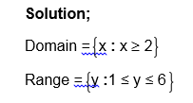

Inverse of a Relation

The Inverse of a Relation Pictorially

Explain the Inverse of a relation pictorially

If there is a relation between two sets A and B interchanging A and B gives the inverse of the relation.

If R is the relation, then its inverse is denoted by R-1

If the relation is shown by an arrow diagram then reversing the direction of the arrow gives its inverse

If the relation is given by ordered pair ( x, y) , then inter changing the variables gives inverse of the relation, that is (y,x) is the inverse of the relation. So domain of R = Range of R -1 and range of R = domain of R-1

Example 13

1.

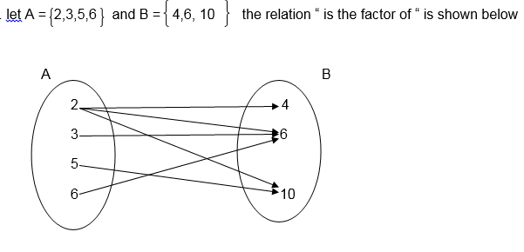

The inverse of this relation is “ is a multiple of “

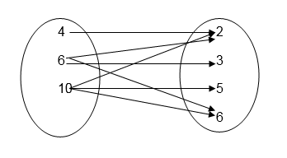

Inverse of a Relation

Find inverse of a relation

Example 14

Find the inverse of the relation R ={ ( x, y):x+ 3 ³ y}

Solution

R-1 is obtained by inter changing the variables x and y.

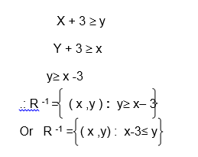

Example 15

Find the inverse of the relation

R ={ ( x , y ): y = 2x }

Solution

R ={( x , y ): y = 2x }

After interchanging the variable x and y, the equation

y = 2x becomes x = 2y

or y = ½ x

so R-1 = ( x, y ) : y = ½ x

Exercise 6

1 .Let A = 3,4,5 and B ‘= 1,4,7 find the inverse of the reaction “ is less than “ which maps an element from set A on to the element in set B

2 .Find the inverse of the relation R = {( x ,y ) : y > x – 1}

3 .Find the inverse of the following relation represented in pictorial diagram

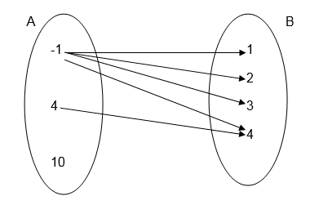

4 .State the domain and range for the relation given in question 3 above

5. State the domain and range of the inverse of the relation given in question 1 above.

A Graph of the Inverse of a Relation

Draw a graph of the inverse of a relation

Use thehorizontal line testto determine if a function has aninverse function.

If ANY horizontal line intersects your original function in ONLY ONE location, your function has an inverse which is also a function.

The functiony= 3x+ 2, shown at the right, HAS aninverse functionbecause it passes the horizontal line test.

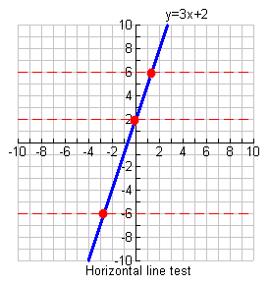

 TOPIC 2: FUNCTIONS

Normally relation deals with matching of elements from the first set called DOMAIN with the element of the second set called RANGE.

Definitions:

A function is a relation with a property that for each element in the domain there is only one corresponding element in the range or co- domain

Therefore functions are relations but not all relations are functions

Representation of a Function

The Concept of a Functions Pictorially

Explain the concept of a functions pictorially

Example 1

Which of the following relation are functions?

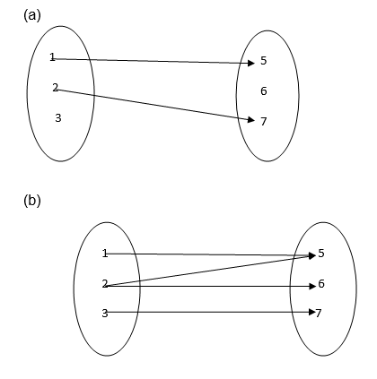

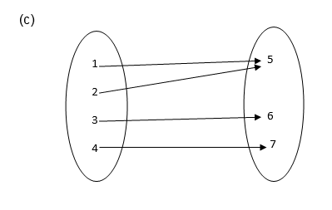

Solution

It is not a function since 3 and 6 remain unmapped.

It is not a function because 2 has two images ( 5 and 6)

It is a function because each of 1, 2, 3 and 4 is connected to exactly one of 5, 6 or 7.

Functions

Identify functions

TESTING FOR FUNCTIONS;

If a line parallel to the y-axis is drawn and it passes through two or more points on the graph of the relation then the relation is not a function.

If it passes through only one point then the relation is a function

Example 2

Identify each of the following graphs as functions or not.

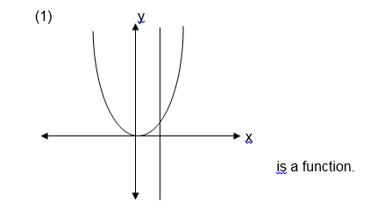

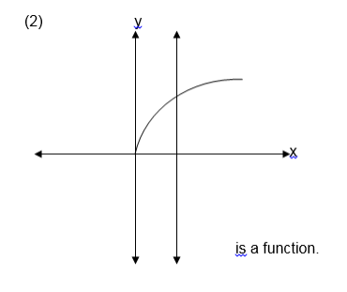

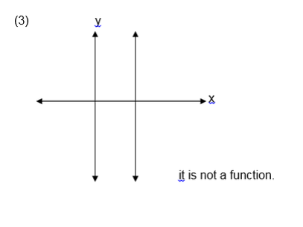

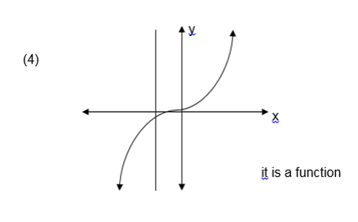

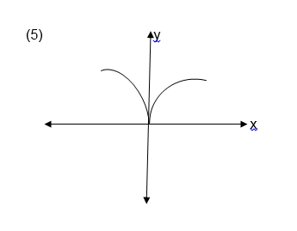

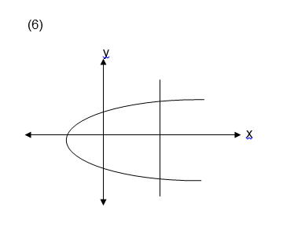

Exercise 1

1. Which of the following relations are functions?

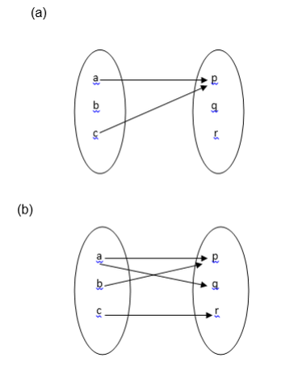

2. Let A = {1, 2, 3, 4, 5, 6, 7, 8, 9, 10}

and B ={ 2, 3, 5, 7 }

Draw an arrow diagram to illustrate the relation “ is a multiple of ‘ is it a function ? why?

3. let A = {1,-1 ,2,-2} and

B = {1, 2, 3, 4 } which of the following relations are functions ?

{ ( x , y ) : x < y }

{ ( x , y ) : x > y}

{ ( x , y ) : y = x2}

Domain and Range of a Function

The Domain of a Function

State the domain of a function

If y = f (x),that is y is a function of x ,then domain is a set of x values that satisfy the equation y = f (x).

The Range of Function

State the range of function

If y = f (x),that is y is a function of x , then therange is a set of y value satisfying the equation y = f (x).

Example 3

1. Let f(x) = 3x – 5 for all value of x such that -2 £ x £ 3 find its range

Solution

f (x) = y = 3x -5

When x = -2

f(-2) = y = 3x(-2)-5 = -11 , so (x,y)=(-2,-11)

f(3) =y= 3x3-5 = 4, so when x = 3 , y = 4

Therefore y is found in between – 11 and 4

Range ={ y: - 11 £ y £ 4}

Example 4

If f (x) = x2 – 3, state the domain and range of f (x)

Solutions;

Domain = all real numbers

Range:

f(x) = y = x2 – 3

Make x the subject

y+ 3 = x2

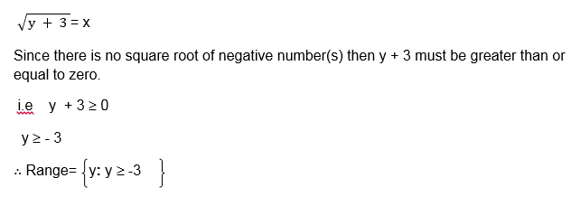

Exercise 2

1. For each of the following functions, state the domain and range

f(x) = 2x + 7 for 2 £ x £ 5

f(x) = x – 1 for -4 £ x £ 6

f(x) = 5 - 3x such that -2 £ f(x) < 8

2. for each of the following functions state the domain and range

f(x) = x2

f(x) = x2+2

f(x) = 2x + 1

f(x) = 1 – x2

Exercise 3

1.The range of the function

f(x) 3 – 2x for 0 ³0 x £7 is;

y: -18£ y £3

y: -3£ y £18

y: 3 £y £18

y: -18 £ y £-3

2. The range of the function

f(x)=2x+1 is y: -3£ y £17 what is the domain of this function?

x: - 3£ x £17

x: - 2£ x £8

x: -17 £ x £3

3.Which of the following relations represents a function:

R = (x, y) : y = for x ≥0

R= (x, y) : y2 = x-2 for x ≥0

R= (x, y) : y = for x ≥0 and y ≥0

R= (x, y) : x = 7 for all values of y

4.Which of the following relations is a function:

R = (x, y): -2 £ x £6, 3 £ y<8 and x<y, Where both x and y are integers

R= (x, y): -2 £ x £6, 3 £ y<8 and x<y, Where both x and y are integers

R= (x,y): y = √(x+2) for x ≥-2.

R = (x, y): y=√(2-x) for x ≤2 and y ≤0

5.Let f (x) = x2 + 1. Which of the following is true?

f (-2) < f (0)

f (3)> f (-4)

f (-5) = f (5)

The function crosses , y – axis at 1

One to one and many to one functions:

One to functions;

A one to one function is a function in which one element from the domain is mapped to exactly one element in the range:

That is if a ≠b then f (a) ≠f (b)

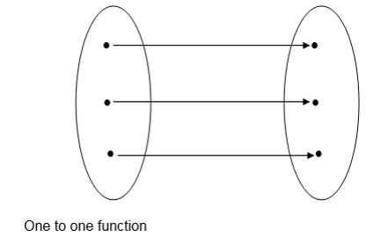

Many to one function;

This is another type of function with a property that two or more elements from the domain can have one image (the same image).

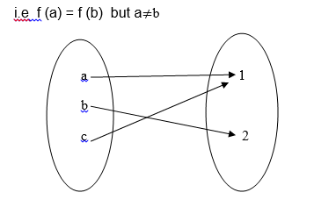

Examples of one to one functions

f (x) = 3x + 2

f (x) = x + 6

f (x) = x3 + 1 etc

Examples of many to one function

f(x) = x2 +1

f(x) = x4 – 2 etc

NB. All functions with odd degrees are one to one function and all functions with even degrees are many to one functions.

Example 5

Let A = -2, -1, 0, 1, 2 and B = 0, 1, 4 and the function f mapping each element from set A to those of B is defined as f(x)=x2.Is f one to one function?



Example 6

Let P = {-2, -1, 0,1,2} and

Q = {-1, 0, 1, 2, 3}

g(x) = x + 1, is g one to one function?

Solution:

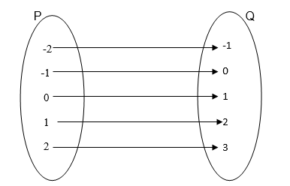

g (x) is one to one function because every element in P has only one image in Q

NB: In example 1, f(x) is not a one to one function because -2 and 2 in A have the same image in B, that is 4 is the image of both 2 and -2.

Also 1 is the image of both 1 nd -1.

Example 7

State whether or not if the following graphs represent a one to one function:

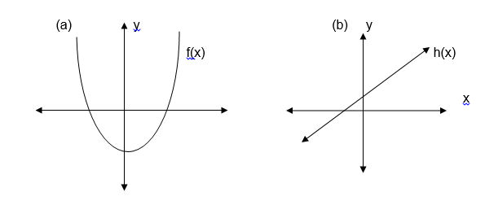

Solution:

Draw a line parallel to the x axis and see if it crosses the graph at more than one points. If it does, then, the function is many to one and if it crosses at only one point then the graph represents a one to one function.

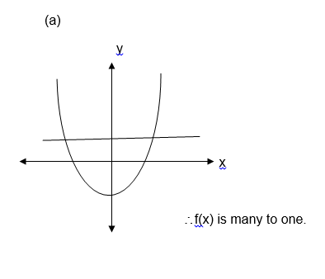

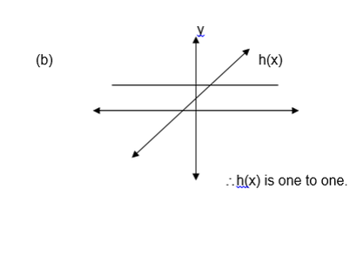

Graphic Function

Graphs of Functions

Draw graphs of functions

Many functions are given as equations, this being the case, drawing a graph of the equation is obtaining the graph of the equation which defines the function.

Note that, you can draw a graph of a function if you know the limits of its independent variables as well as dependent variables. i.e you must know the domain and range of the given function.

Example 8

Draw the graph of the following functions

f(x) = 3x -1

g (x) = x2 – 2x -1

h (x) = x3

Solution

f(x) = 3x – 1

The domain and range of f are the sets of all real numbers

f(x) = y = 3x – 1

So y = 3x – 1

Table of value :

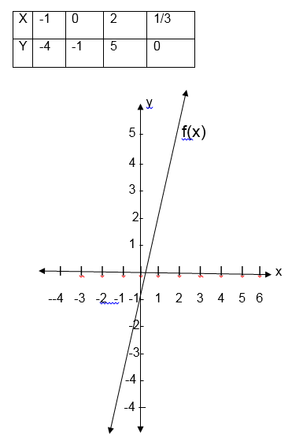

g(x) = x2 -2x -1

y=x2-2-1

a=-1, b=-2 1 and c=-1

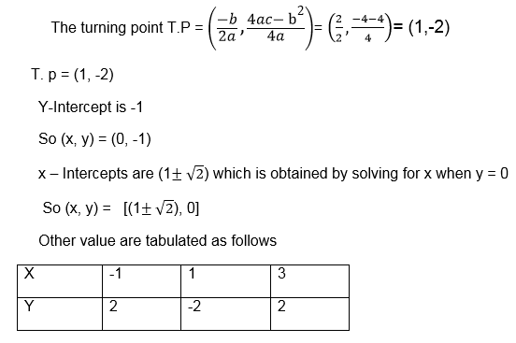

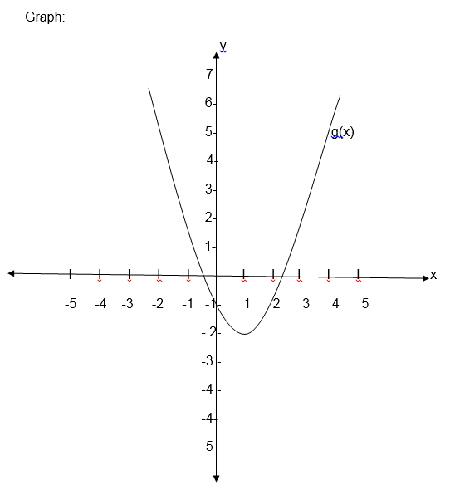

forh(x) = x3

Solution:

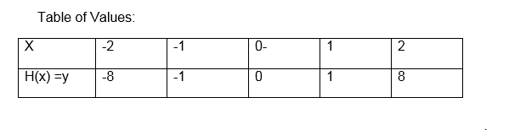

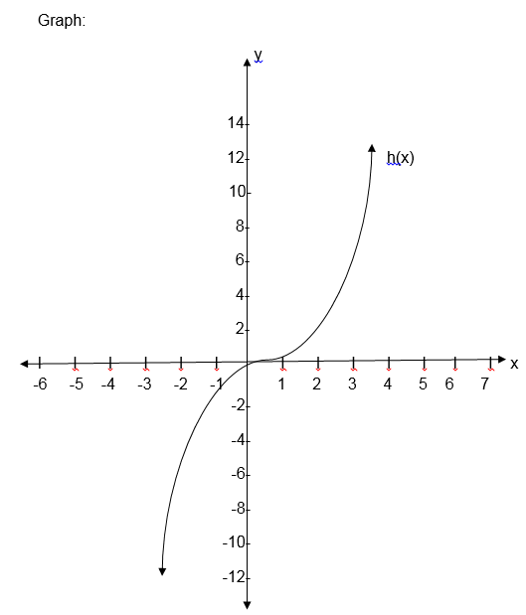

The first graph is the graph of linear function, the second one is called the graph of a quadratic function and the last graph is for cubic function.

Example 9

Draw a graph of the function:

f(x) = -1 + 6x-x2

Solution:

a=-1, b=6, c=-1

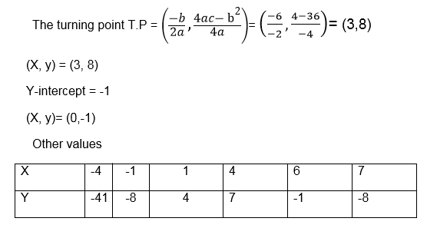

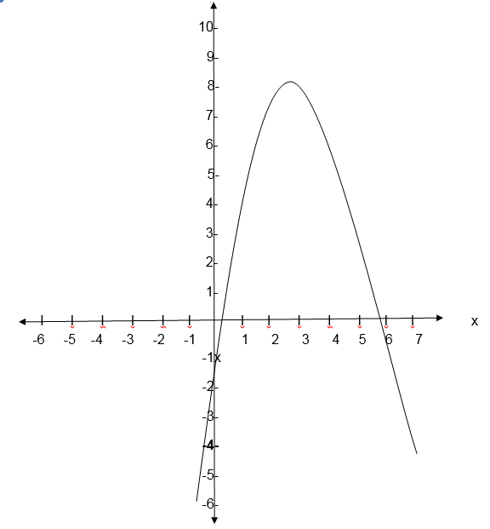

Exercise 4

1.Which of the following are one to one function?

f(x) = 3x – x2

g (x) = x-1

k(x) =x3+1

f(x) =x+x2+x3

k(x)=x4

2. Draw the graph of the following functions:

f(x) = 3x – x2

h (x) = x+1

g(x) =x 3- x 2+3

3. At what values of x does the graph of the function f(x) = x2+x-6 cross thex- axis?

x=-3 and x=7

x=8 and x=-6

x=-3 and x=2

x=4 and x=-1

4. Which of the following function is one to one function?

f(x)=x2+2

f(x) =x4-x2

f(x)=x5-7

f(x)=x2+x+2

Functions with more than one part.

Some functions consist of more than one part. When drawing their graphs draw the parts separately.

If the graph includes an end point, indicate it with a solid dot if it does not include the end point indicate it with a hollow dot.

E.g. draw the graphs of the functions

(a) F(x) x+1 for x>0

(b) f(x)=x+1for x³g0

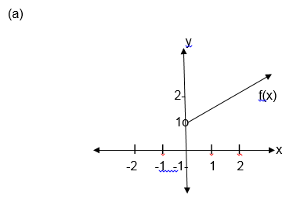

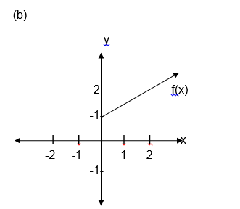

Example 10

Solved.

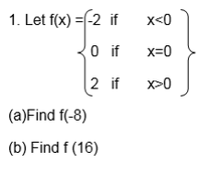

(c) Sketch its graph

(d) State the domain and range of f

Solution:

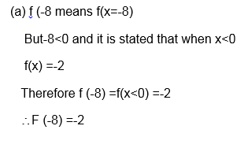

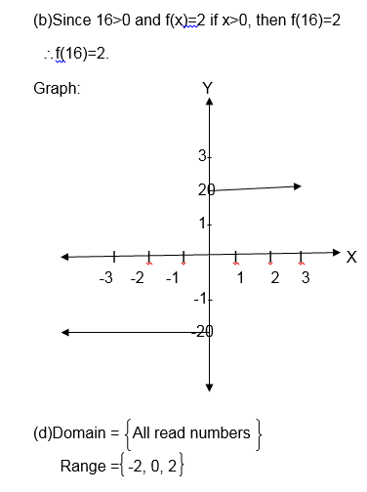

Exercise 5

Sketch the graph of each of the following functions and for each case state the domain and range.

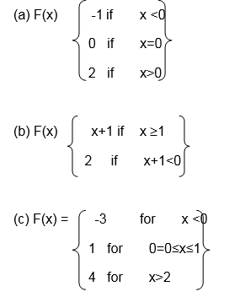

Absolute value functions (Modulus functions)

The absolute function is defined

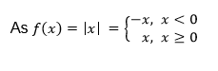

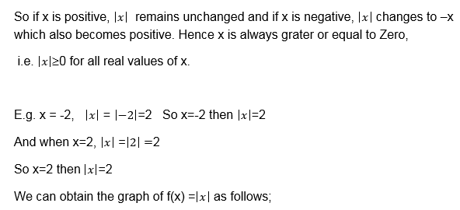

Table of values

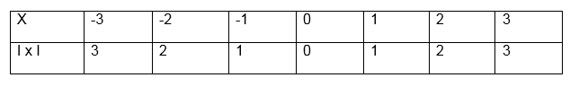

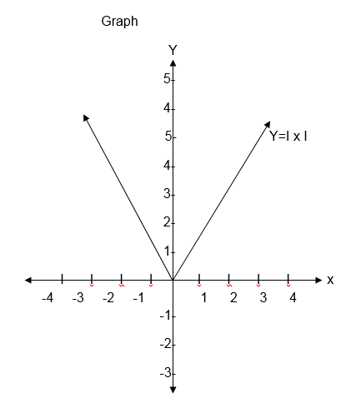

Example 11

Solve the following <!--[endif]-->

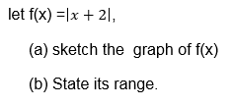

Solution

table of values.

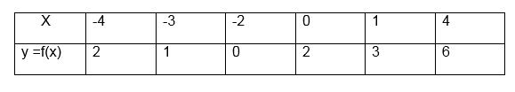

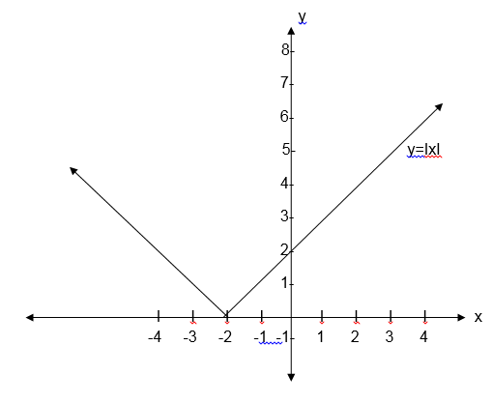

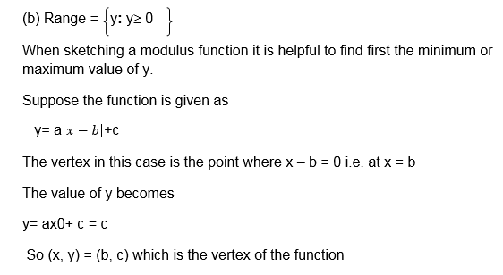

Step functions:

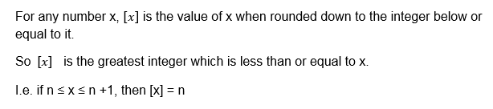

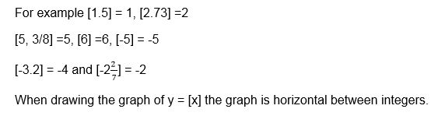

Example 12

Draw the graph of

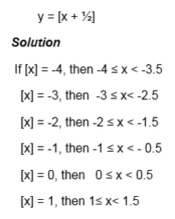

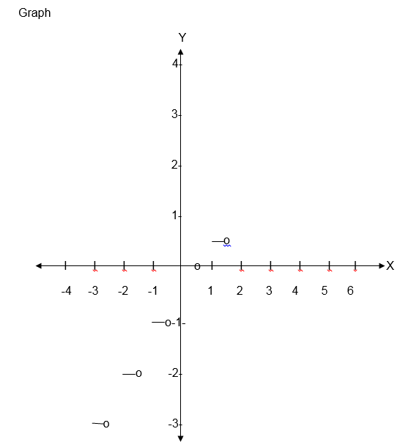

Note that the graph obtained is like steps such functions are called steps functions

Exercise 6

1. Draw the graph of

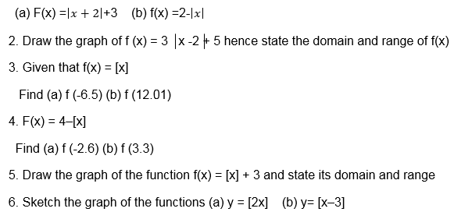

Inverse of a Function

The Inverse of a Function

Explain the inverse of a function

In the discussion about relation we defined the inverse of relation.

It is true that the inverse of the relation is also a relation.

Similarly because a function is also relation then every function has its inverse

The Inverse of a Function Pictorially

Show the inverse of a function pictorially

According to the definition of function the inverse of a function is also a function if and only if the function is one to one

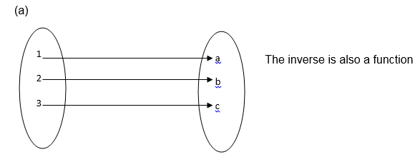

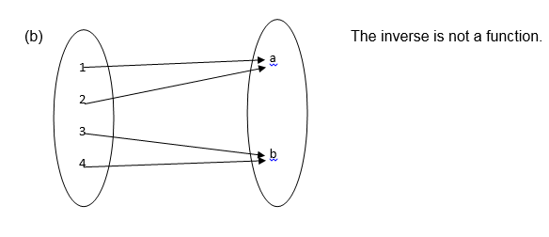

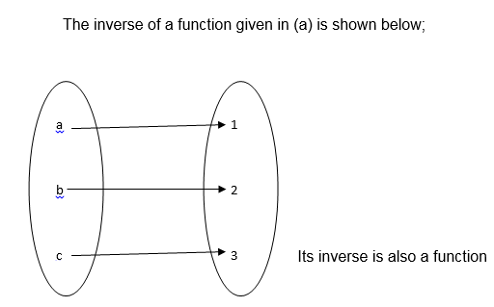

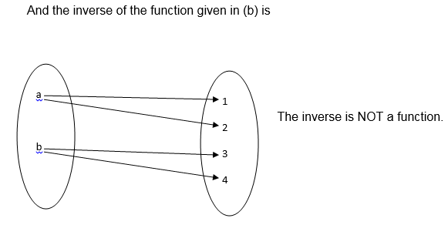

The Inverse of a Function

Find the inverse of a function

If the function f is one to one function given by an equation, then its inverse is denoted by f-1 which is obtained by inter changing the variables x and y then making y the subject of the formula.

I.e. If y=f(x), then x = f-1 (y)

Example 13

1. Find the inverse of each of the following functions;

F(x) = 3x-6

F(x) =x3

Solution:

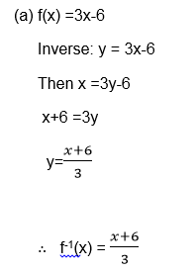

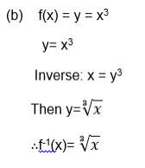

A Graph of the Inverse of a Function

Draw a graph of the inverse of a function

Example 14

find the inverse of the function f(x) = x-5 and then sketch the graph of f-1(x) , also state the do

,solution:

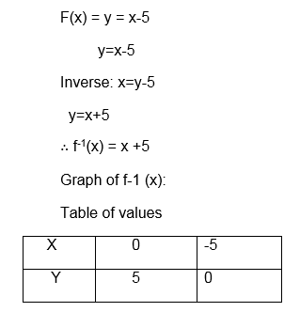

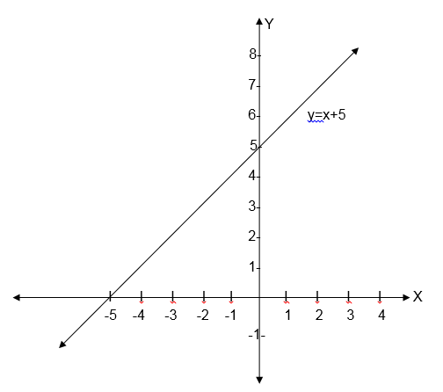

Domain = {All real numbers}

Range = {All real numbers}

NB: if a function f takes a domain A to a range B, then the inverse f-1 takes B back to A.

Hence the domain of f-1 is the range of f, and the range of f-1 is the domain of f.

The Domain and Range of Inverse of Functions

State the domain and range of inverse of functions

Example 15

Solve;

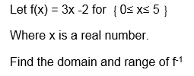

Solutions:

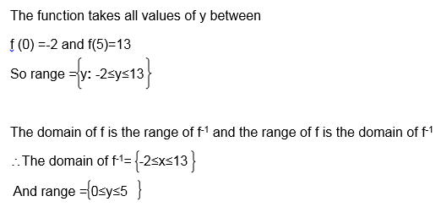

Exercise 7

1.Find the inverse of each of the following functions:

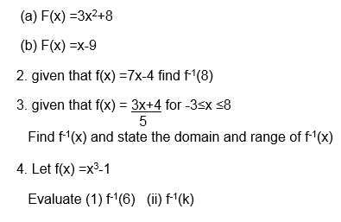

Exercise 8

1. given that f(x) = x2-2[x] +3, what is the value of f (-4)?

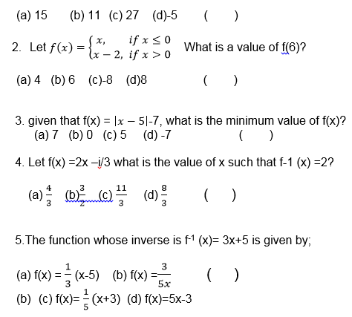

**TOPIC 3: STATISTICS**

**Mean**

Calculating the Mean from a Set of Data, Frequency Distribution Tables and Histogram

Calculate the mean from a set of data, frequency distribution tables and histogram

Measures of central tendency:

After collecting the data, organizing it and illustrating it by means of diagrams, there is a need to calculate certain statistical measures to describe the data more precisely. There are various types of measures of central tendency – the arithmetic mean (or simply the mean), the median, and the mode. Once the measures of central tendency are found, it is easier to compare two or more sets of data.

The arithmetic mean

When people are asked to find the measure of central tendency of some numbers, they usually find the total of the numbers, and then divide this total by however many numbers there are. This type of measure of central tendency is the arithmetic mean. If the n values are x1+x2+x3 ………+xn then the arithmetic mean is = x1 + x2+ ….. + xn/n

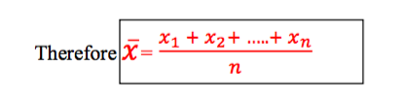

Example 1

The masses of some parcels are 5kg, 8kg, 20kg and 15kg. Find the mean mass of the parcels.

**Solution**

Total mass = (5 + 8 + 20 + 15) kg = 48kg

The number of parcels = 4

The mean mass = 48kg ÷ 4 = 12kg

The arithmetic mean used as measure of central tendency can be misleading as can be seen in the following example.

Example 2

John and Mussa played for the local cricket team. In the last six batting innings, they scored the following number of runs.John: 64, 0, 1, 2, 4, 1;Mussa: 15, 20, 13, 11 , 10, 3.Find the mean score of each player. Which player would you rather have in your team? Give a reason.

**Solution**

John’s mean = (64 + 0 + 1 + 2 + 4 + 1) ÷ 6 = 12

Mussa’s mean = (15 + 20 + 13 + 11 + 10 + 3) ÷ 6 = 12

Each player has the same mean score. However, observing the individual scores suggests that they are different types of player. If you are looking for a steady reliable player, you would probably choose Mussa.

Often it is possible to use the mean of one set of numbers to find the mean of another set of related numbers.

Suppose a number a is added to or subtracted from all the data. Then a is added to or subtracted from the mean.

Suppose the n values are 𝑥!+𝑥! + 𝑥! .........+𝑥!. Multiply each by a, and we obtain 𝑎𝑥!+𝑎𝑥! + 𝑎𝑥! .........+𝑎𝑥!. So we see that the mean has been multiplied by a.

Interpreting the Mean Obtained from a Set Data, Frequency Distribution Tables and Histogram

Interpret the mean obtained from a set data, frequency distribution tables and histogram

Measures of central tendency from frequency tables

If the data has already been put into a frequency table, the calculation of the measures of central tendency is slightly easier.

Exercise 1

Juma rolled a six- sided die 50 times. The scores he obtained are summarized in the following table.Calculate the mean score

|  |  |  |  |  |  |  |
| --- | --- | --- | --- | --- | --- | --- |
| Score (x) | 1 | 2 | 3 | 4 | 5 | 6 |
| Frequency (f) | 8 | 10 | 7 | 5 | 12 | 8 |

**Solution**

10 scores of 2 give a total 10 x 2 = 20

8 scores of 1 gives a total 8 x 1 = 8

And so on, giving a total score of

8 x 1 +10 x 2+7 x 3 + 5 x 4 + 12 x 5 + 8 x 6 = 177

The total frequency = 8 + 10 + 7 + 5 + 12 + 8 = 50

The mean score = 177 ÷ 50 = 3.34

**Medium**

The Concept of Median

Explain the concept of median

Mr.Samwel owns a small factory. He earns about 4,000,000/- from it each year. He employs 4 people. They earn 550,000/-, 500,000/-, 450,000/- and 400, 000/-.The mean income of these five people is(4,000,000 + 550,000 + 500,000 + 450,000 + 400,000 ÷ 5 = 1,180,000/-

If you said to one the employees that they earned about 1,180,000/- each year they would disagree with you. In this type of situation when one of the values is different from the others (as in Example 2), the mean is not the best measure of central tendency to use.Arrange the incomes in increasing order of size as follows:

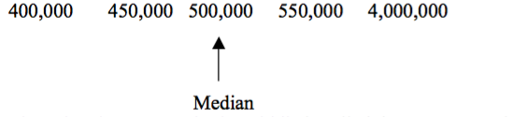

The value that appears in the middle is called the median. In this case the value of 500,000/- is a much better idea of the average wage earned by the employees. The median is not affected by isolated values (sometimes called rogue values) that are much larger or smaller than the rest of the data.

If the data consists of an even number of values, find the mean of two middle values as shown in the next example.

The Medium from a Set of Data

Calculate the medium from a set of data

Example 3

Find the median of the numbers: 12, 23, 10, 8, 22, 14, 30, and 18.

**Solution**

Arranging in increasing order of size, we get 8 10 12 14 18 22 23 30

Median = (14 + 18) ÷ = 16

The Median using Frequency Distribution Tables and Cumulative Curve

Find the median using frequency distribution tables and cumulative curve

Example 4

Juma rolled a six- sided die 50 times. The scores he obtained are summarized in the following table. Calculate the modianl score

**Solution**

here are 50 items of data, so if you arrange them in order of size, the positions are1 .................... 25 and 26 ................. 50. The median will be the average of the 25th and 26th number.

In the table there are 8 scores of 1, followed by 10 scores of 2. This gives you 8 + 10 = 18 numbers. These are then followed by 7 scores of 3. This gives 18 + 7 = 25 numbers. It follows that the 25th number is a 3. The 26th number must be the first number in the next group, which is a 4.

The median is then = (3 + 4) ÷ 2 = 3.5

The Median Obtained from the Data

Interpret the median obtained from the data

Exercise 2

1. The times of five athletes in the 100 m were: 12.5 s, 12.9s, 14.8s, 15.0s, 25.2s. Find the median time. Why is the median a better measure of central tendency to use than the mean?
2. Iddi has 6 maths tests during a school term. His marks are recorded below. Find the mean and the median mark. Explain why the median is a better measure of central tendency than the mean 73 78 82 0 75 86
3. The table below gives the percentage prevalence of HIV infection in female blood donors for the years 1992 to 2003. Find the mean and median of these figures.

|  |  |  |  |  |  |  |  |  |  |  |  |
| --- | --- | --- | --- | --- | --- | --- | --- | --- | --- | --- | --- |
| 1992 | 1993 | 1994 | 1995 | 1996 | 1997 | 1998 | 1999 | 2000 | 2001 | 2002 | 2003 |
| 5.9 | 6.2 | 4.8 | 9.4 | 8.2 | 11.6 | 11.8 | 12.6 | 13.3 | 13.7 | 12.3 | 11.9 |

**Mode**

The Concept of Mode

Explain the concept of mode

The mode is value that occurs most often in a set of data.This is another measure of central tendency. It is possible for data to have more than one mode.

Data with two modes are said to be bi – modal.Why mode? The mode is often important to know. For example:

1. If you ran a shoe shop you would want to know the most popular size.
2. If you ran a restaurant you would want to know what type of food is ordered most.

The Mode

Calculate the mode

Example 5

State the mode for the following sets of numbers:

1. 0, 0, 1, 1, 1, 2, 2, 3, 4, 5, 5
2. 58, 57, 60, 59, 50, 56, 62
3. 5, 10, 10, 10, 15, 15, 20, 20, 20, 25

**Solution**

1. 1 occurs most (3 times): The mode is 1
2. All the numbers appear once: There is no mode.
3. There are three 10s and three 20s: Modes are 10 and 20.

Exercise 3

1. Ten pupils were asked how many brothers or sisters they had. The results are recorded below. Find the mode number 0, 1 , 1, 2, 5, 0, 1 3 , 1 and 4.
2. Eight motorists were asked how many times they had taken the driving test before they passed. The results are recorded below. Find the mode number. 14213141
3. Give examples of where the mode is a better measure of central tendency than either the mean or the median.
4. Find the mode of these sets of numbers.
5. 0, 1, 1, 3, 4, 5, 5, 5, 6, 7, 8
6. 3, 8, 4, 3, 8, 4, 3, 8, 8, 3, 3, 4
7. 5, 12, 6, 5, 11, 12, 5, 5, 8, 12, 7, 12
8. 3, 6, 2, 8, 2, 1, 9, 12, 15

Finding the Mode using Frequency Distribution and a Histogram

Find the mode using frequency distribution and a histogram

Grouped data

Suppose a set of data consists of many different values, such as heights of people measured to the nearest centimeter. Then the data is grouped, for example into 160 – 165 cm, and so on. If the data has been grouped together in classes, then unless you have a list of all the individual values, you only know approximately what each value is. For this reason, you can only estimate the mean and the median. Also, if all the values are different, you do not have a single value as the mode. Instead you have a modal class, as shown in the example below.

Data grouped in classes can be illustrated by a histogram.Suppose one of the intervals is from 10 to 19, where data has been rounded to the nearest whole number. The class limits are 10 and 19. The data in this interval could be as low as 9.5 or as high as 19.5. These are the class boundaries. The width of the interval is the difference between the class boundaries, in this case it is 10.

The histogram consists of rectangles between the class boundaries, with height corresponding to the frequency. The area of each rectangle is proportional to the frequency.

Example 6

The examination results (rounded to the nearest whole number %) are given for a group of students.

|  |  |  |  |  |  |
| --- | --- | --- | --- | --- | --- |
| Mark (%) | 30 – 39 | 40 -49 | 50 – 59 | 60 - 69 | 70 - 79 |
| Frequency | 5 | 3 | 20 | 2 | 10 |

1. Draw a histogram
2. state the modal class

**Solution**

For a histogram, the horizontal axis is for the data values, and the vertical axis is for the frequencies. So label the horizontal axis with the marks from 30 to 80. To indicate that the axis does not start at 0 put a zig – zag to the left of 30. Label the vertical axis with frequencies from 0 to 20. The first interval has limits 30 and 39. The class boundaries are 29.5 and 39.5. It has a frequency of 5. So draw a box covering the interval, and with height 5. Repeat with the other intervals

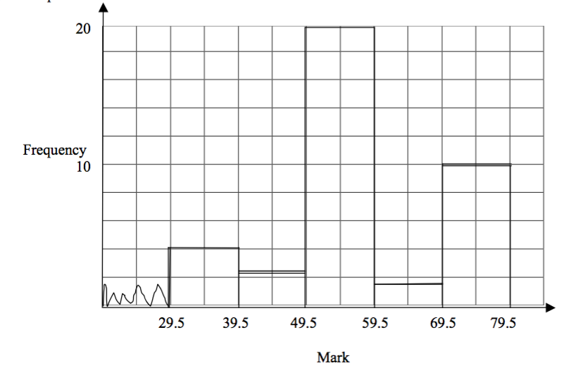

Interpreting the Mode Obtained from the Data

Interpret the mode obtained from the data

Example 7

The examination results (rounded to the nearest whole number %) are given for a group of students.

|  |  |  |  |  |  |
| --- | --- | --- | --- | --- | --- |
| Mark (%) | 30 – 39 | 40 -49 | 50 – 59 | 60 - 69 | 70 - 79 |
| Frequency | 5 | 3 | 20 | 2 | 10 |

Estimate the mode

**Solution**

To estimate the mode, there are two methods.

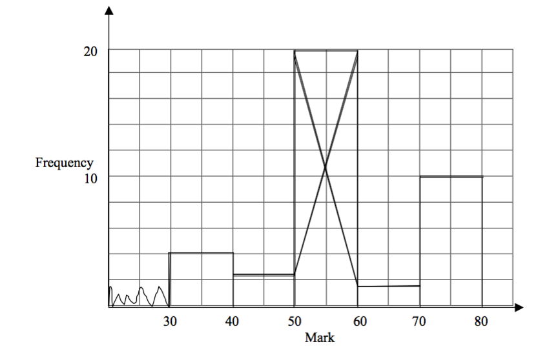

**By drawing:**Use the histogram of the first part.Then proceed as follow;

* Step 1: Draw a straight line from the top left hand corner of the rectangle of the modal class, to the top left hand corner of the rectangle of the class to the right of the modal class.
* Step 2: Draw a line from the top right hand corner of the rectangle of the modal class,to the top right of the modal class to the left of the modal class.
* Step 3: Find where these two lines intersect. This gives the mode as 54 on the horizontal axis.

**By calculation:**Let

* fM = frequency of the modal group
* fR = frequency of the group to the right of the modal group
* fL = frequency of the group to the left of the modal group
* W = width of the modal group
* L = lower class boundary of the modal group

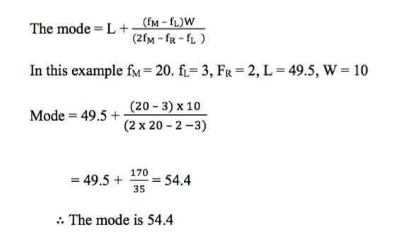

**TOPIC 4: RATES AND VARIATIONS**

**Rates**

A rate is found by dividing one quantity by another.

Rates of Quantities of Different Kinds

Relate rates of quantities of different kinds

For example a rate of pay consists of the money paid divided by the time worked. If a man receives 1,000 shilling for two hours work, his rate of pay 1000 ÷ 2 = 500 shillings per hour. From the above example, we find out that

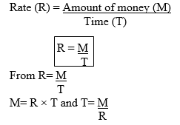

Example 1

1. A man is paid 6,000/= for 8 hours work.

1. What is his rate of pay?
2. At this rate, how much would he receive for 20 hours work?
3. At this rate, how long must he work to receive 30,000 shillings?

***Solution*:**

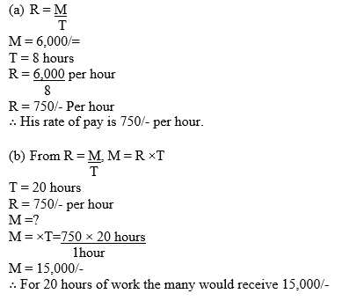

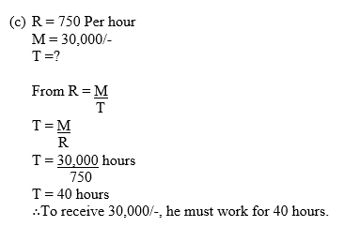

Quantities of the Same Kind

Relate quantities of the same kind

Example 2

A student is growing plants she measures the rate at which two of them are growing. Plant A grew 5cm in 10 days, and plant B grew 8cm in 12 days. Which plant is growing more quickly?



Exercise 1

1. A woman is paid 12,000/= for 8 hours work.



Converting Tanzanian Currency into other Currencies

Convert Tanzanian currency into other currencies

Different countries have different currencies. Normally money is changed from one currency to another using what is called a Rate of Exchange.

This makes trade and travel between countries convenient.

Conversion of money is done by multiplying or dividing by the rate of exchange.

Eg. If at a certain time there are 1,100 shillings to each UK pound (£), to go from £to shillings, multiply by 1,100, and to go from shillings to £divide by 1,100.

**NB:** The rate of exchange between two countries varies from time to time.

Example 3

Suppose the current rate of change between the Tanzanian shillings and the Euro is 650 Tsh per Euro.

1. A tourist changes 200 euros to Tsh. How much does he get?
2. A business woman changes 2,080,000 Tsh to euros. How much does she get?



Exercise 2

At a certain time there are 600 Tsh to one US dollar ($).



**Variations**

The Concept of Direct Variation

Explain the concept of direct variation

Some quantities are connected in such a way that they increase and decrease together at the same rate. Afar example if one quantity is doubled the other quantity is also doubled. These quantities are Directly Proportional or Vary Directly.

Eg. If a car is driven at a constant speed, the distance it goes is directly proportional to the time taken.

Also the amount of maize you buy is directly proportional to the amount of money you spend.

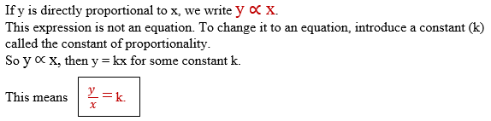

Problems on Direct Variations

Solve problems on direct variations

Example 4

1. Suppose different weights are hung from a wire. The extension of the wire is proportional to the weight hanging.

Suppose a weight of 2kg gives an extension of 5cm.

Find an equation giving the extension e cm in terms of weight w kg. Find the weight for an extension of 3cm.

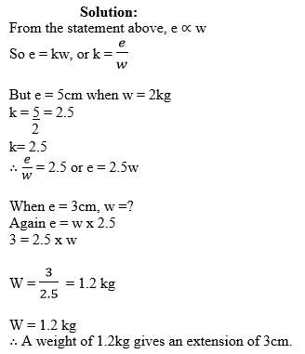

Example 5

Given that y is proportional to x such that, when x = 40, y = 5. Find an equation giving y in terms of x and use it to find (a) y when x = 15 (b) x when y = 20.

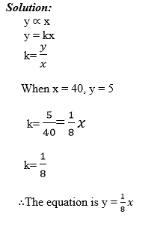

Exercise 3

The variables m and n are directly proportional to each other such that when m = 3, n= 12.

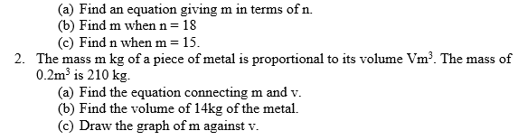

Graphs of Direct Variation

Draw graphs of direct variation

Example 6

The linear equation graph at the right shows that as the*x*value increases, so does the*y*value increase for the coordinates that lie on this line.

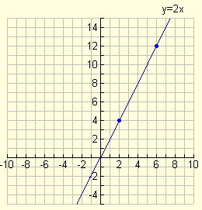

This is a graph of**direct variation**

The Concept of Inverse Variation

Explain the concept of inverse variation

In some cases one quantity increase at the same rate as another decrease. For example, if the first quantity is doubled, the second quantity is halved.

In this case the quantities vary inversely, or they are inversely proportional. e.g. The number of men employed to dig a field is inversely proportional to the time it takes. Also the time to travel a journey is inversely proportional to the speed. We use the same symbol (∝) for proportionality.

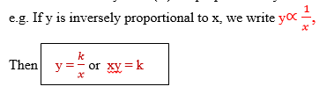

Problems on Inverse Variations

Solve problems on inverse variations

Example 7

1. Suppose a mass of a gas is kept at a constant temperature. The volume of the gas is inversely proportional to its pressure.

If the volume is 0.8m3 when the pressure when the is 250kg/m3, find the formula giving the volume vm3 in terms of the pressure P kg/m2. What is the volume when the pressure is increased to 1,000kg/m2?

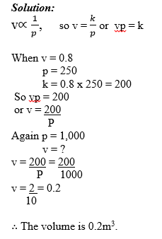

Example 8

Given that y is inversely proportional to x, such that x = 8 when y = 15. Find the formula connecting x and y by expressing y in terms of x and use it to find (a) y when x = 10, (b) x when y = 3

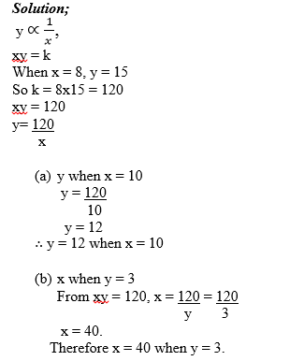

Exercise 4

The quantities p and q are inversely proportional to each other such that when q = 20, p=1.2

1. Find the equation giving p in terms of q
2. Find q when p = 0.5
3. Find p when q = 160

Given that y is inversely proportional to x such that when y = 6, x =7. Find the equation connecting x and y by expressing x in terms of y and hence find x when y = 36

The number of workers needed to repair a road is inversely proportional to the time taken. If 12 workers can finish the repair in 10 days, how long will 30 workers take?

Graphs Relating Inverse Variations

Draw graphs relating inverse variations

The graph of y against x is shown for which y = 3 when x =2

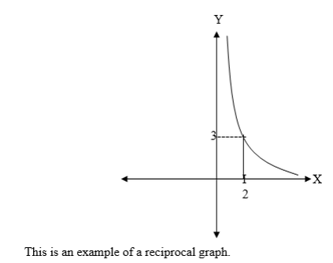

**Proportion to powers:**

Sometimes a quantity is proportional to a power of another quantity. For example the area A of a circle is proportional to the square of its radius r,

So A ∝r2 or A= kr2

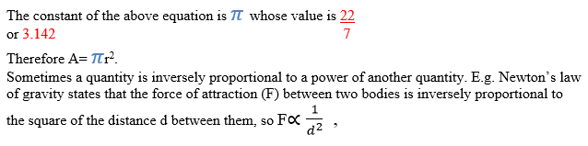

Example 9

1. The mass of spheres of a certain metal is proportional to the cube of their radii. A sphere of radius 10cm has mass 42kg. Find the formula giving the mass m kg in terms of radius r cm. Find the radius of the sphere with mass 5.25 kg.

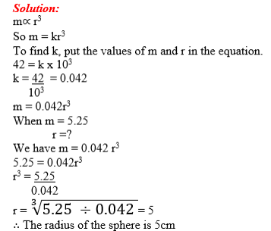

Example 10

Given that M is proportional to the square of N and when N = 0.3, M = 2.7. Find the equation giving M in terms of N, and hence find the value of:

1. M when N = 1.5
2. N when M = 0.3

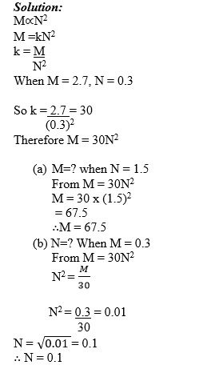

Joint Variation in Solving Problems

Use joint variation in solving problems

If a quantity varies as the product of two other quantities then it varies jointly with them. eg. If y = 3vu2, then y varies jointly with v and u2.



Example 11

1. Suppose a mass of a gas with volume Vm3 is under pressure P kg/m2 and has absolute temperature T0.

The volume of the gas varies jointly with its absolute temperature and inversely with its pressure. At a temperature of 300 k and pressure of 80kg/m2, the volume is 0.5m3. Find the formula for the volume in terms of T and P.

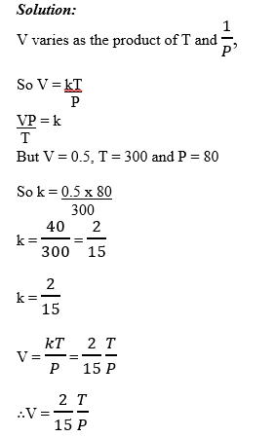

Example 12

m varies jointly with p and q such that when p = 12 and q = 5 then m= 15. Find m in terms of p and q and hence find m when P = 3 and q = 28

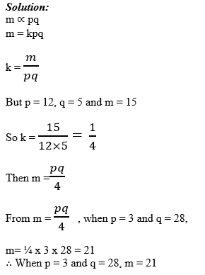

Exercise 5

1. M is inversely proportional to the cube of N, when N =2 then M = 20.

1. Find an equation giving M in terms of N.
2. Find M when N = 4
3. Find N when M = 5.

2. P is inversely proportional to the square root of Q. When Q = 16 then P =5.

1. Find an equation connecting P and Q expressing P in terms of Q.
2. Find P when Q = 9

3. When a body is moving rapidly through the air, the air resistance R newtons is proportional to the square of the velocity Vm/s, At a velocity of 50m/s, the air resistance is 20N.

1. Find R in terms of V
2. Find the resistance at 100m/s.

4. B varies jointly with A and the inverse of C. When A = 3 and C = 12 then B = 20.

1. Find B in terms of A and C.
2. Find B when A = 8 and C= 2

5. The mass m kg of a solid wooden cylinder varies with the height h (m) and with the square of the radius r (m). If v = 0.2 and h = 1.4, then M = 150. Find m in terms of h and r.

Joint variation leading to areas and volumes

Many formulas for areas and volumes involve joint variation. For example the volume of a cylinder is given by v = πr2h.

So the volume varies jointly with the height and the square of the radius. i.e v∝r2h.

Example 13

1. A cylinder has radius 3cm and volume 10cm3. If the radius of the base is increased to 4cm without altering the height of the cylinder what effect does this have on the volume?

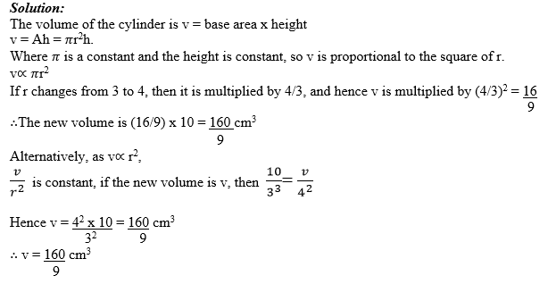

Example 14

A pyramid has a square base. If the height decreases by 10% but the volume remains constant, what must the side of the base increase by? (i.e What increase in the side will of set the decrease in the height?).

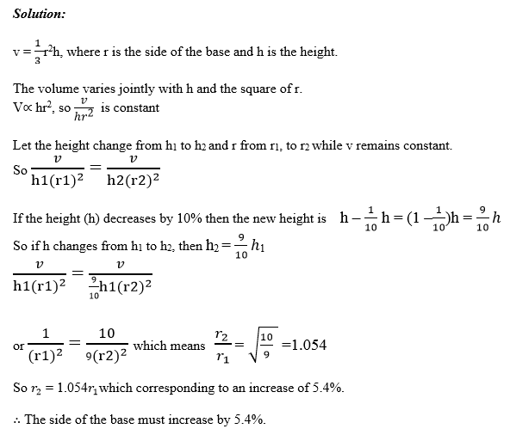

Exercise 6

1. A box has a square base of side 5cm. The volume of the box is 56cm3. If the sides increase by 10%, without the height changing, what is the new volume of the box?

2. A cone has volume 30cm3. If the radius increases by 10% and the height by 5%, what is the new volume of the cone?

3. A water tank holds 1,000 liters, and is in the shape of cuboids. The lengths of the sides of the base are enlarged by a scale factor of 1.4 without altering the height. What volume will the tank now hold?

4. The height of a cylinder is reduced by 20%. What percentage change is needed in the radius, if the volume remains constant?

TOPIC 5: SEQUENCE AND SERIES

Sequences

The Concept of Sequence

Explain the concept of sequence

A Sequence is the arrangement of numbers or is a list of numbers following a clear pattern such that one number and the next are separated by comma (,).

Example: a1, a2, a3, a4 ……………………..

NB: Each number found in a Series or Sequence is called a term.

Example 1

Find the next three terms in the following sequences.

5, 8, 11, 14, 17,………………………………

3, 7, 6, 10, 9, …………………………………

1, 2, 4, 7, ………………………………………

2, 9, 20, 35, …………………………………

Solution:

(a)You can see that each term is less to the next by 3.

So next three terms are (17+3),(17+3+3) and 17+3+3x3)

Which are 20, 23, and 26

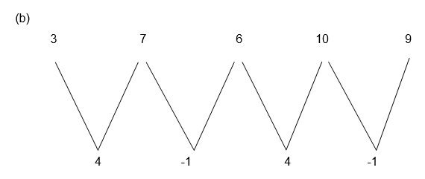

Alternately add 4 and subs tract 1. The sequence then extends to 13, 12, 16

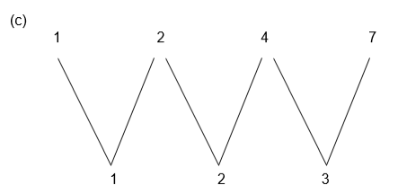

We see that the difference is increasing by 1 each time. So the next three terms are 11, 16 and 22.

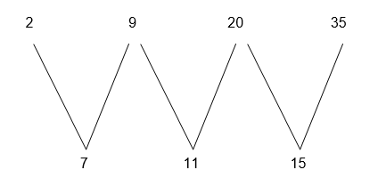

The differences are increased by 4 each time, so the next three terms are 54, 77 and 104.

Example 2

Write down the first three terms in the sequences where the nth term is given by the formulae.

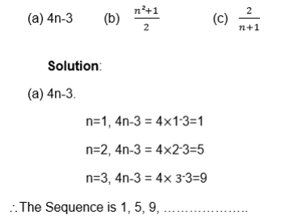

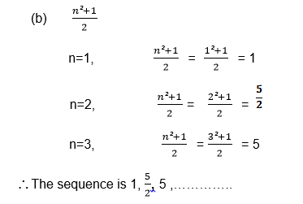

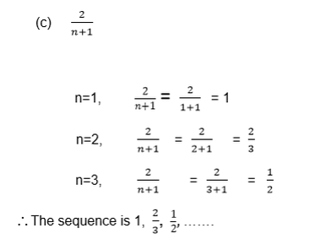

Example 3

The kth term of a series is k2 + 4

Find the sum of the first four terms in the series

Solution:

k=1, k2+4=12+4=5

k=2, k2+4=22+4=8

k=3, k2+4=32+4=13

k=4, k2+4=42+4=20

So the series is 5+8+13+20 and its sum is 46

Example 4

Find the nth term of the following sequences:

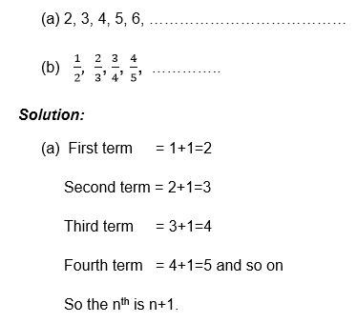

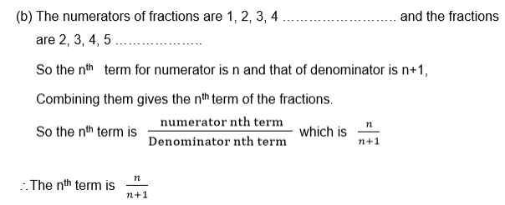

Exercise 1

1. Write down the next three terms in the following sequences

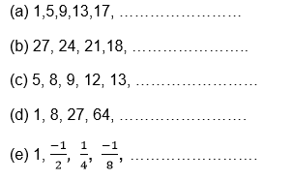

2. Find the first three terms in the sequence:

5n+2

1-3k

n2+n+1

2n

3. Find the sum of the first four terms of the series where the kth term is given by:

5k+3

k3-1

2k

4. Find the nth term of these sequences:

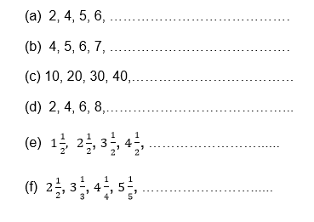

An Arithmetic Progression (AP) and Geometric Progression (GP)

Identify an arithmetic progression (AP) and geometric progression (GP)

When the series or sequence is such that between two consecutive terms there is a difference which is fixed, then the series or sequence is called an arithmetic progression (A.P)

The fixed difference (number) between two consecutive terms is called the common difference (d)

Example 5

In the sequence 4, 7, 19, 13, 16 there is a common difference which is

7-4=10-7=13-10=16-13=3.

So the common difference (d)=3.

Note that in arithmetic progression (A.P) the difference between two successive terms is always the same.

Sometimes numbers may be decreasing instead of increasing, the arithmetic sequence or series while terms decrease have a negative number as a common difference.

Example 6

The common difference of the sequence 6, 4, 0, -2, …………………… is

4-6=2-4=0-2=-2-0=-2

So the common difference is -2.

In general if A1, A2, A3, A4, ……………………… An are the terms of the arithmetic sequence , then the common difference is ;

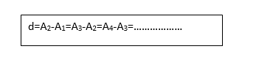

Example 7

For each of the following sequences, find the common difference and write the next two terms.

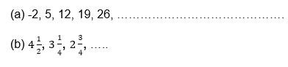

Solution:

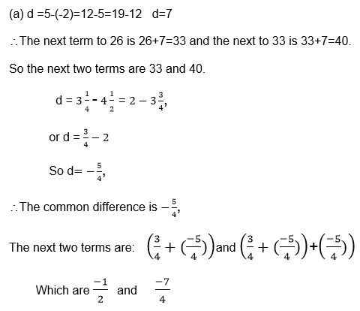

Exercise 2

1. Find the common difference for each of the following sequence:

11, 14, 17, 20, …………………………………

2, 4, 6, 8, 10, ……………………………………

0.1, 0.11, 0.111, 0.1111 , …… … … … … …

y, y+3, y+6, y+9, y+12, … …… … … … ……

2. State whetherthe following sequence are arithmetic or not:

2, 5, 8, 11, 14, …………… ……………… ……

1, 3, 4, 6, 7, 9, 10, ………………………………

y, y + x, y+2x, y+3x, … ………… ……

3. The temperatureat a mid day is 30c, and it falls by 20c each hour. Find the temperature at the end of the next four hours.

Geometric Progression (G.P).

When the series or Sequence is such that between two consecutive terms there is a ration which is fixed, then the series or sequence is called a geometric progression (G.P)

The fixed ratio(number) between two successive terms is called the common ratio (r).

Example 8

In 2, 4, 8, 16, 32, … … …… … … …….

There is a common ration which is

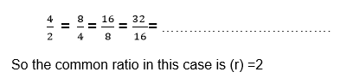

Note that like in arithmetic progression (A.P), in geometric progression (G.P) the common ratio does not change.

Also the terms may be decreasing instead of increasing, the geometric sequence or series whose terms decrease have a positive common ratio which is less than 1 for the progression with positive terms.

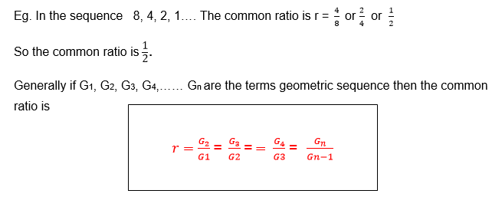

Example 9

For each of the following sequence find the common ratio.

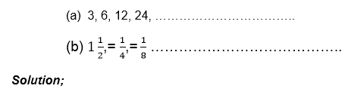

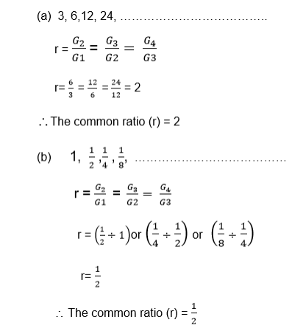

Example 10

For the following geometric sequences, find the common ratio and write down the next two terms:

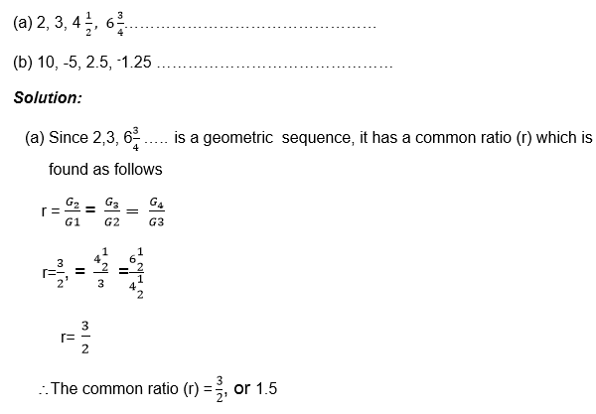

The next term is found by multiplying the term considered to be the last term by the common ratio.

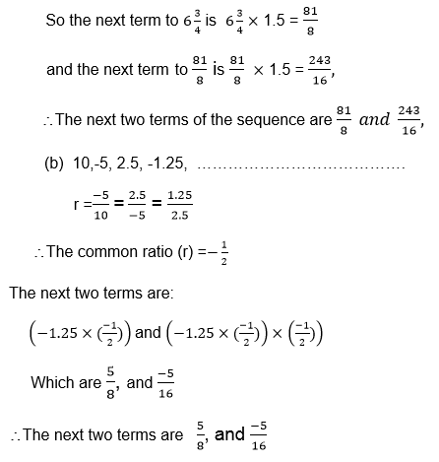

Exercise 3

1. Which of the following sequences are geometric

1, 2, 4, 8, 16, ……………………………………

2, 6, 18, 54, 162, …………………………………

1, -1,1,-1,1, ………………………………………

x2, 2x3, 4x4, 8x3…………………………………

1, 2, 4, 7, 10, ………………………………………

0.1, 0.2, 0.3, 0.4, 0.5, ……………………………

3, 6, 9, 12,15, ……………………………………….

2. Find thecommon difference for each of the following geometric progressions (G.P)

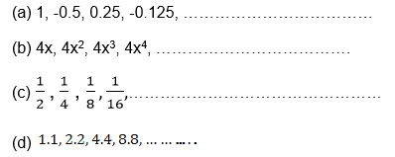

3. Find thenext term of the sequence 2, 10, 50, 500,………………….

4. The populationof a town is decreasing so that every year the population declines by a quarter. If the population is originally 100,000. What will it be after 5 years?

The General Term of an AP

Find the general term of an AP

If A1, A2, A3, …………………An are the terms of an arithmetic sequence, then there is a common difference d which is given by

d = A2 – A1 = A3 – A2 = An – An – 1

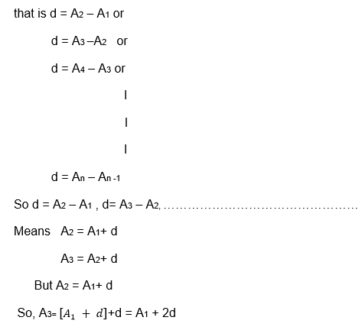

But . A3 = A1 + 2d which means

A4 =[ A1+2d]+d

= A1 + 3d

Putting into consideration this pattern, it is true that

A5 = A1 + 4d

A6 = A1 + 5d

An = A1 + (n-1)d

Where An is the nth term

The nth term of the sequence with first term A1 and common difference d is given by

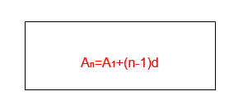

Example 11

Find theformula for the nth term of the sequence 8 , 9.5, 11, 12.5, 14, 15.5,……

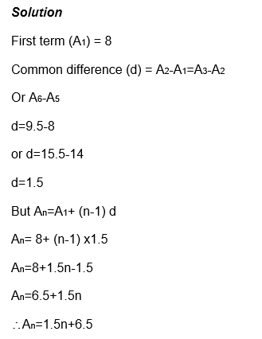

Note that the nth term gives every term in the sequence,

For example when n=3, you have A3=1.5x3+6.5=11

So A3=11 where 11 is given in the sequence above having the third position.

Therefore An shows the position of the term in sequence and of A1+(n-1)d gives the value of the term for any positive integer.

Example 12

The 5th term of an arithmetic sequence is 11, and the 8th term is 26. Find the first five terms.

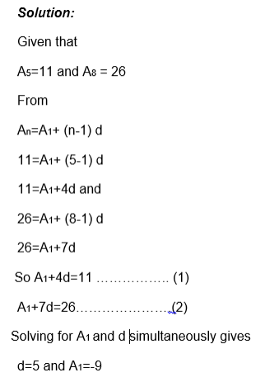

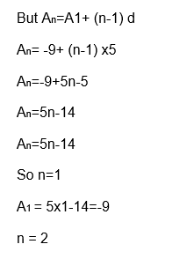

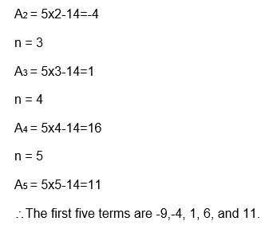

Example 13

The 8th term of an arithmetic sequence is 9 greater than the 5th term, and the 10th term is 10 times the 2nd term. Find

The common difference (d)

20th term.

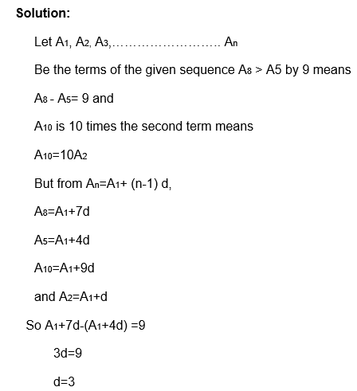

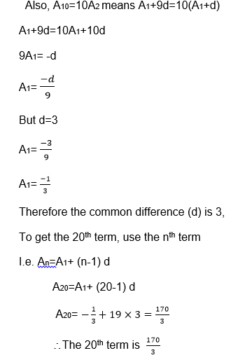

The General Term of GP

Find the general term of GP

If G1, G2, G3,……………..Gn are the terms of a geometric sequence, then they have a common ratio (r) which is given by

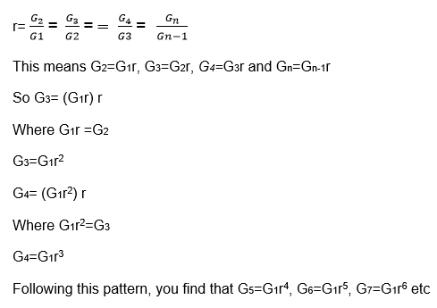

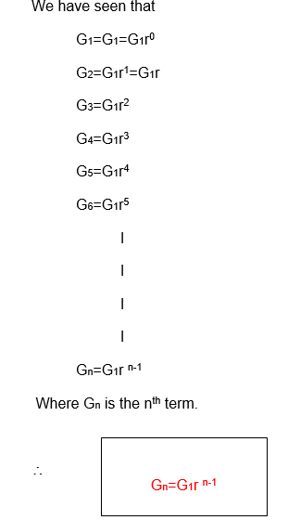

Example 14

Find the formula for the nth term of each of the following geometric sequence.

2, 6, 18, 54 , ………………………………

4,-2, 1, -0.5, 0.25 …………………………

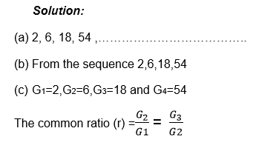

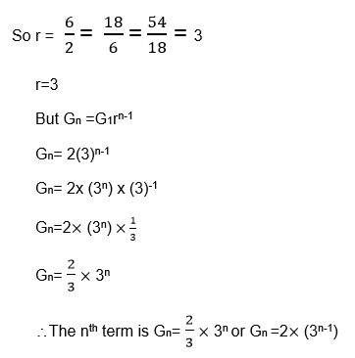

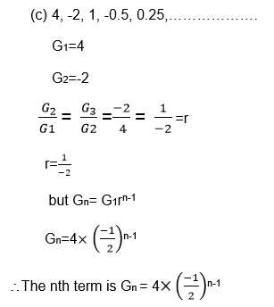

Example 15

Considering that,

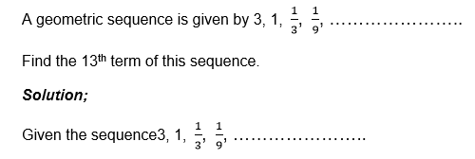

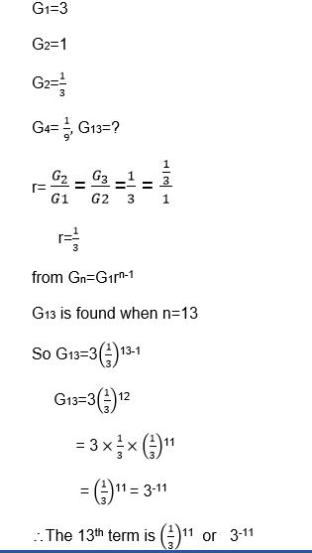

Exercise 4

1. In the arithmetic sequence, the 17th term is 30 and 9th term is 42 find the first three terms.

2. In the Arithmeticsequence the third term 12 and the 9th term 24. Find the nth term of the sequence and use it to find the 15th term.

3. Find the15th term of the sequence 5, 10, 20, 40 ,…………………………

4. A population isincreasing and every year it is multiplied by 1.03. If it starts off at 10,000,000, what will it be after n years?

5. The first termof the geometric sequence is 7 and the common ratio is 4. What is the 9th term of this sequence?

Series

The Formula for a Sum of an Arithmetic Progression

Derive the formula for a sum of an arithmetic progression

When the terms are separated by addition (+) sign, there we have what we call a series.

Example: 2+4+6+8+……………………………

Is a series with the first term (A1) 2 and common difference (d) 2

It is possible to establish a formula for the sum of the first n terms of the arithmetic progression.

Let Sn denote the sum of the first n terms of the arithmetic series.

Consider the sum of the first 5, terms of arithmetic progression (AP) whose first term is 1 and whose common difference (d) is 1.

So S5 = A1+A2+A3+A4+A5

S5=1+2+3+4+5 ………………………….. (1)

The first case is the sum of five terms which are increasing from 1 up to 5 while the second case shows the same sum but the terms are decreasing from 5 to 1.

If you add (1) and (2) together, you find that

S5+S5=(1+5) + (2+4) +(3+3) + (4+2) + (5+1)

25s = 6+6+6+6+6

255=30

Dividing by 2 each side gives

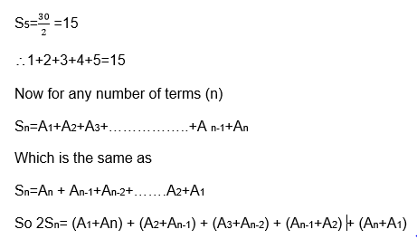

Also we can write

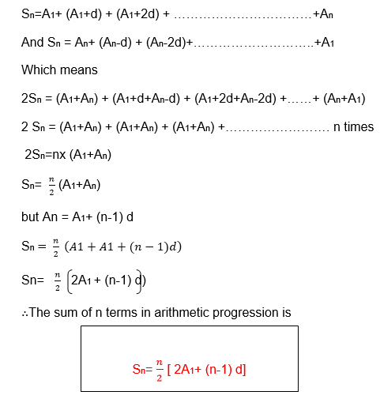

Example 16

Findthe sum of the first 20 terms of the series

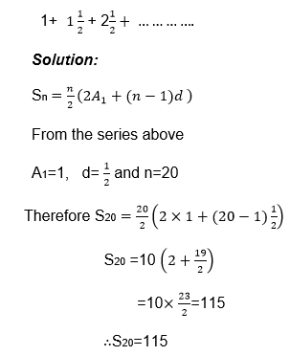

Example 17

Find the sum of the series 4+7+10+13+…………….+304

Solution:

To use the formula for summation of n terms, you must know how many terms are there, i.e finding the value of n;

Now

A1=4, d=3 and An = 304 n=?

An =A1+ (n-1)d

304 = 4+ (n-1)x3

304 = 4+3n-3

304=3n+1

304=3n

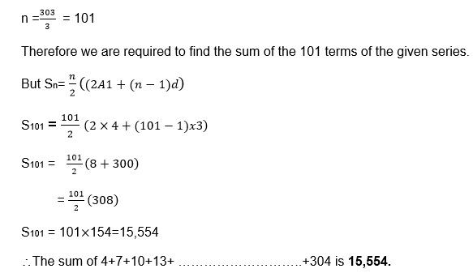

Example 18

How many terms of the series 1+3+5+7+………………. are needed to make the sum of 169?

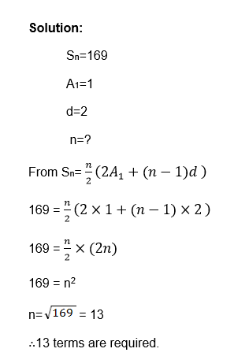

Exercise 5

1. Find thesum of the first 20 terms of the series

2+5+8+11+……………………

19+16+13+10+7+……………

2. Find thenumber of terms and the sum of the series:

1+3+5+7+ ……………………………………

40+37+34+31+…………………+-257

3. The sumof the first 10 terms of an arithmetic progression (A.P) is 40, and the sum of the next 10 terms is 80. Find the sum of the first five terms of the series.

4. One dayFrola spends 40 minutes of her home work. The length of time she spends increase by 4 minutes each day. Find the total length of time she spends after eight days.

The Arithmetic Mean

Calculate the arithmetic mean

Remember that the arithmetic mean (M) of n numbers is found by adding them and then dividing the sum by n, e.g the arithmetic mean of a,b,c and d is

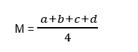

The Formula for the Sum of a Geometric Progression

Derive the formula for the sum of a geometric progression

Geometric series are the series that can be written as

G1+G2+G3+ ………………………..Gn

Example: 2+4+8+16+ ………………………..+Gn

Or 1+3+9+27+81+…………………….

Suppose we want to find the sum of 1+3+9+9+27+81+…………………

S5=!+3+9+27+81……………………….(1)

If we multiply sn by the common ratio(r), we have.

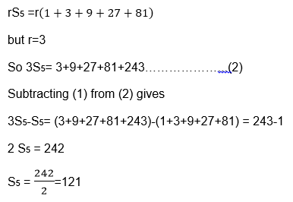

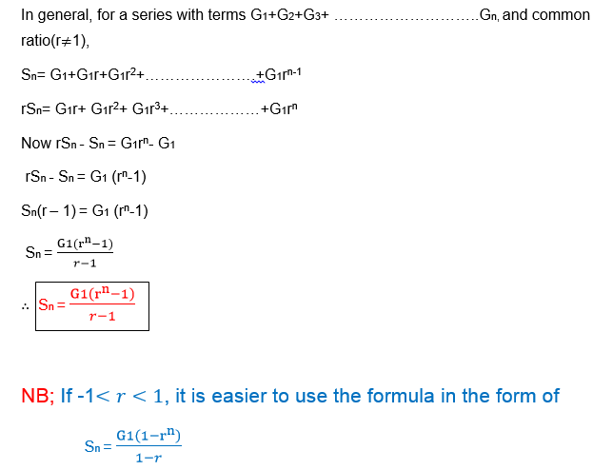

Example 19

1. Find the sum of the geometric series 2+4+8+ ………………..+2048

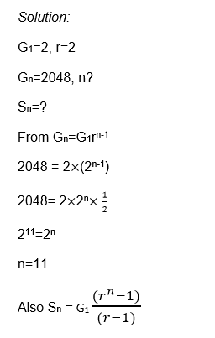

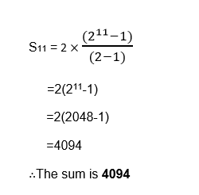

Example 20

Find the sum of the first 8 terms of the series 5+20+80+320+ ……………

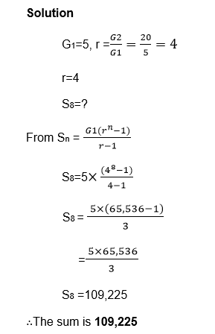

Exercise 6

1. For each ofthe following series, find the number of terms and hence the sum of the series.

1+3+9+…………………+729

1-2+4-8+………………+1,024

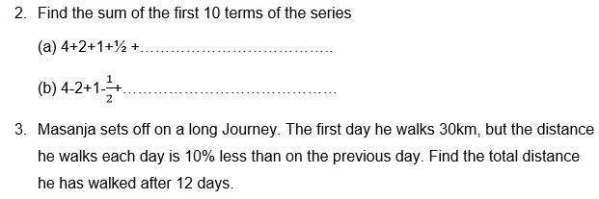

The Geometric Mean

Calculate the geometric mean

The Geometric mean (GM) of n positive numbers is found by taking the nth root of their product.

Example 21

The Geometric mean of a, b, c and d is

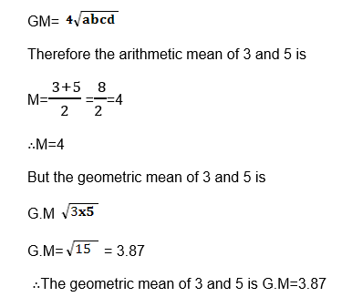

The arithmetic mean and geometric mean can be used to check that a sequence is an arithmetic or geometric respectively.

FACTS:

If a, b and c are consecutive three term of arithmetic progression (A.P), then b is the arithmetic mean of a and c

If a, b and c are three consecutive terms of geometric progression (G.P), then b is the geometric mean (G.M) of a and c.

Proof:

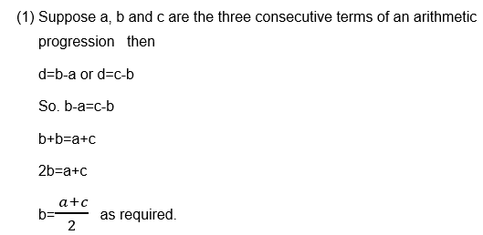

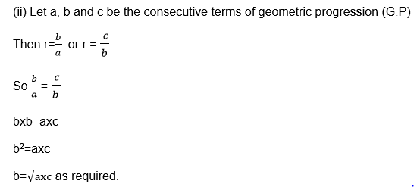

Example 22

Find the arithmetic and geometric means of

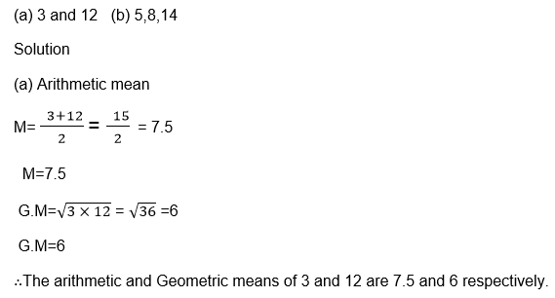

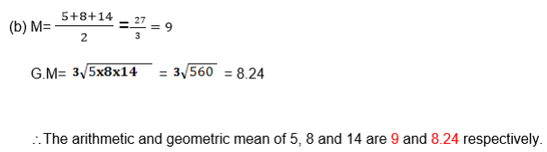

Exercise 7

1. Find the arithmetic and geometric means of the following;

x1, x3

4x, 9x

4a, 25a.

2. The arithmeticmean and geometric mean of two numbers are 7.5 and 6 respectively. Find the two numbers.

Compound Interest

Compound Interest using Formula

Calculate compound interest using formula

Suppose money is invested or borrowed. At the end of a year, interest is calculated. Suppose this interest is added to the original principal, and at the end of the next year interest is added to the new principal. This process may be continued for a number of years.

This process is called COMPOUND INTEREST.

When money is invested at a compound interest, the amount of money increase as a geometric sequence.

Example 23

Ibrahimu invested 20,000/= at 6% compound interest. How much was there after 5 years?

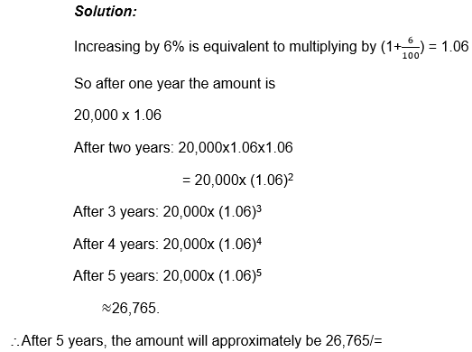

Now let the principal be P, the rate R% and the time in years be n.

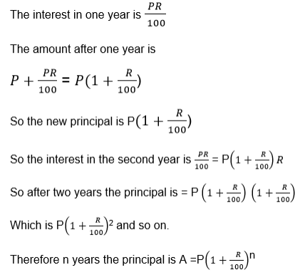

Example 24

At the beginning of each year Martha invests 10,000/= at 5% compound interest. How much does she have at the end of the 10th year?

Solution:

She has made 10 different investments each giving different amount of interest.

The 1st investment has had 10 years of interest, hence it is 10,000 x (1.05)10

The 2nd investment has had 9years of interest. So it is 10,000 x (1.05)9

The 3rd investment has had 8 years of interest. Hence it is 10,000 x (1.05)8

Following this pattern,

The 10th investment has had 1 year of interest. Hence it is 10,000x1.05.

The sum of all these amounts is given by;

10,000x1.0510 +10,000 x1.059+ 10,000x1.058+……………+10,000x1.05

This geometric series with first term 10,000 x 1.05 and common ratio 1.05.

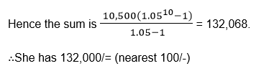

Exercise 8

1. Find thetotal amount of the following savings if they earn compound interest.

100,000/= for 2years at 6% p.a

250,000/= for 3 years at 4.5% p.a

400,000/= for 20years at 5.5% p.a

2. A populationis increasing at 2% if it starts at 10,000,000 what will it be after 20 years.

3. At the beginning of each year 600,000/= is invested at 6% compound interest.Find the total value of the investment at the end of the 15th year.

TOPIC 6: CIRCLES

Definition of Terms

Circle, Chord, Radius, Diameter, Circumference, Arc, Sector, Centre and Segment of a Circle

Define circle, chord, radius, diameter, circumference, arc, sector, centre and segment of a circle

A circle: is the locus or the set of all points equidistant from a fixed point called the center.

Arc: a curved line that is part of the circumference of a circle

Chord: a line segment within a circle that touches 2 points on the circle.

Circumference: The distance around the circle.

Diameter: The longest distance from one end of a circle to the other.

Origin: the center of the circle

Pi(π):A number, 3.141592..., equal to (the circumference) / (the diameter) of any circle.

Radius: distance from center of circle to any point on it.

Sector: is like a slice of pie (a circle wedge).

Tangent of circle: a line perpendicular to the radius that touches ONLY one point on the circle.

NB: Diameter = 2 x radius of circle

Circumference of Circle = PI x diameter = 2 PI x radius

Central Angle

The Formula for the Length of an Arc

Derive the formula for the length of an arc

Circumference of Circle = PI x diameter = 2 PI x radius where PI =𝝅= 3.141592...

The Central Angle

Calculate the central angle

A central angle is an angle formed by two intersecting radii such that its vertex is at thecenter of the circle.

<AOB is a central angle. Its intercepted arc is the minor arc from A to B.

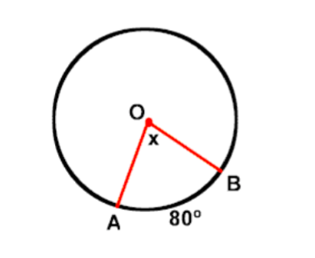

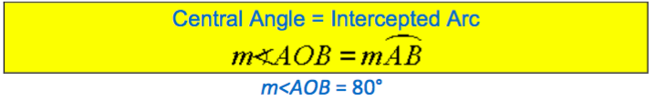

The Concept of Radian Measure

Explain the concept of radian measure

Radians are the standard mathematical way to measure angles. One radian is equal to the angle created by taking the radius of a circle and stretching it along the edge of the circle.

The radian is a pure mathematical measurement and therefore is preferred by mathematicians over degree measures. For use in everyday work, the degree is easier to work with, but for purely mathematical pursuits, the radian gives better results. You probably will never see radian measures used in construction or surveying, but it is a common unit in mathematics and physics.

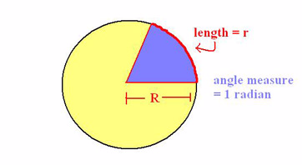

Radians to Degree and Vice Versa

Convert radians to degree and vice versa

The unit used to describe the measurement of an angle that is most familiar is thedegree. To convert radians to degrees or degrees to radians, the following relationship can be used.

angle in degrees = angle in radians * (180/pi)

So, 180 degrees = pi radians

Example 1

Convert 45 degrees to radians

Solution

45 = 57.32*radians

radians = 45/57.32

radians = 0.785

Most often when writing degree measure in radians, pi is not calculated in, so for this problem, the more accurate answer would beradians = 45 pi/180 = pi/4

Example 2

Convert pi/3 radians to degree

degrees = (pi/3) * (180/pi)

degrees = 180/3 = 60°

Angles Properties

Circle Theorems of Inscribed Angles

Prove circle theorems of inscribed angles

Aninscribedangle is formed when two secant lines intersect on a circle. It can also be formed using a secant line and a tangent line intersecting on a circle. Acentral angle, on the other hand, is an angle whose vertex is the center of the circle and whose sides pass through a pair of points on the circle, therefore subtending an arc.In this post, we explore the relationship between inscribed angles and central angles having the same subtended arc. The angle of the subtended arc is the same as the measure of the central angle (by definition).

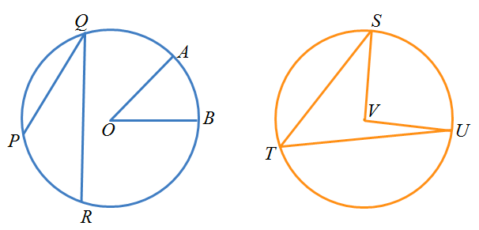

In the first circle,is a central angle subtended by arc. Angleis an inscribed angle subtended by arc. In the second circle,is an inscribed angle andis a central angle. Both angles are subtending arc.

What can you say about the two angles subtending the same arc? Draw several cases of central angles and inscribed angles subtending the same arc and measure them. Use a dynamic geometry software if necessary. Are your observations the same?

In the discussion below, we prove one of the three cases of the relationship between a central angle and an inscribed angle subtending the same arc.

Theorem

The measure of an angle inscribed in a circle is half the measure of the arc it intercepts. Note that this is equivalent to the measure of the inscribed angle is half the measure of the central angle if they intercept the same arc.

Proof

Letbe an inscribed angle andbe a central angle both subtending arcas shown in the figure. Draw line. This forms two isosceles trianglesandsince two of their sides are radii of the circle.

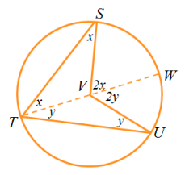

In triangle, if we let the measure ofbe, then angleis also. By theexterior angle theorem, the measure of angle. This is also similar to triangle. If we let angle, it follows thatis equal to 2y. In effect, the measure of the inscribed angleand the measure of central anglewhich is what we want to prove.

The Circle Theorems in Solving Related Problems

Apply the circle theorems in solving related problems

Example 3

An arc subtends an angle of 200 at the center of the circle of radius25cm.Find the length of this arc.

Solution

r =25cm, 𝜽=20°

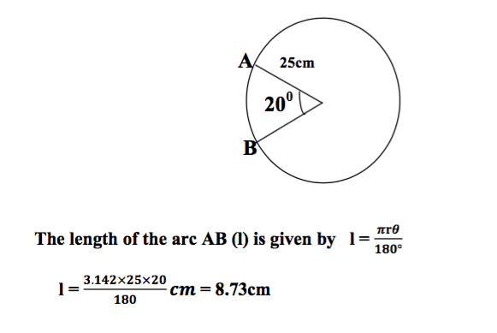

The length of the arc is 8.73cm.

Example 4

An arc of length 5cm subtends 50° at the center of the circle, what is theradius of the circle?

l=5cm, 𝜽=50°, r=?

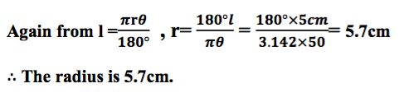

Chord Properties of a Circle

Chord Properties of a Circle

Identify chord properties of a circle

Imagine that you are on one side of a perfectly circular lake and looking across to a fishing pier on the other side. The chord is the line going across the circle from point A (you) to point B (the fishing pier). The circle outlining the lake's perimeter is called thecircumference. Achord of a circleis a line that connects two points on a circle's circumference.

To illustrate further, let's look at several points of reference on the same circular lake from before. If each point of reference (i.e. duck feeding area, picnic tables, you, water fountain, and fishing pier) were directly on this lake's circumference, then each line connecting a point to another point on the circle would be chords.

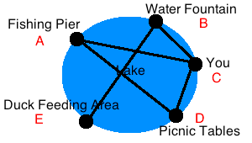

The line between the fishing pier and you is now chord AC

The line between the water fountain and duck feeding area is now chord BE

The line between you and the picnic tables is chord CD

If we had a chord that went directly through the center of a circle, it would be called adiameter. If we had a line that did not stop at the circle's circumference and instead extended into infinity, it would no longer be a chord; it would be called asecant.

The Theorem on the Perpendicular Bisector to a Chord

Prove the theorem on the perpendicular bisector to a chord.

Proof of Theorem

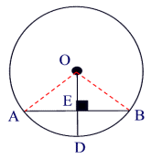

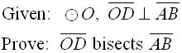

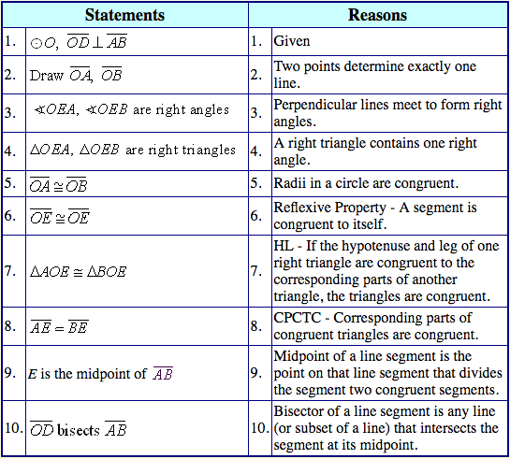

The Theorem on Parallel Chords

Prove the theorem on parallel chords

Parallel chords in the same circle always cut congruent arcs. Parallel chords intercept congruent arcs.

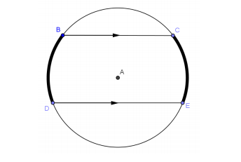

Construct a diameter perpendicular to the parallel chords.

What does this diameter do to each chord? The diameter bisects each chord.

Reflect across the diameter (or fold on the diameter). What happens to the endpoints?The reflection takes the endpoints on one side to the endpoints on the other side. It, therefore, takes arc to arc. Distances from the center are preserved.

What have we proven? Arcs between parallel chords are congruent.

The Theorems on Chords in Solving Related Problems

Apply the theorems on chords in solving related problems

Example 5

The figure is a circle with centreO. GivenPQ= 12 cm. Find the length ofPA.

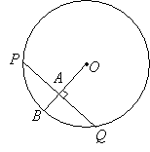

Solution:

The radiusOBis perpendicular toPQ. So,OBis a perpendicular bisector ofPQ.

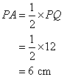

Example 6

The figure is a circle with centreOand diameter 10 cm.PQ= 1 cm. Find the length ofRS.

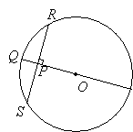

Solution:

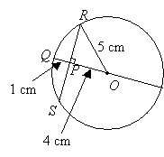

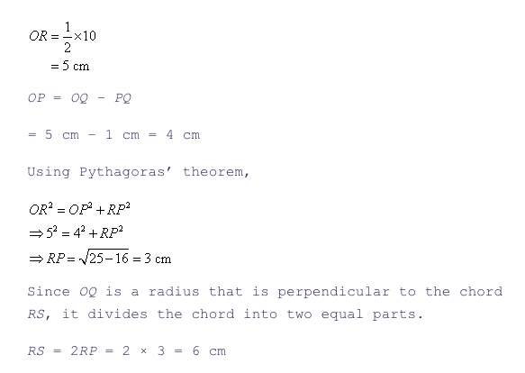

Tangent Properties

A Tangent to a Circle

Describe a tangent to a circle

Tangent is a line which touches a circle. The point where the line touches the circle is called the point of contact. A tangent is perpendicular to the radius at the point of contact.

Tangent Properties of a Circle

Identify tangent properties of a circle

A tangent to a circle is perpendicular to the radius at the point of tangency. A common tangent is a line that is a tangent to each of two circles. A common external tangent does not intersect the segment that joins the centers of the circles. A common internal tangent intersects the segment that joins the centers of the circles.

Tangent Theorems

Prove tangent theorems

Theorem 1

If two chords intersect in a circle, the product of the lengths of the segments of one chord equal the product of the segments of the other.

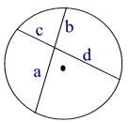



Intersecting Chords Rule: (segment piece)×(segment piece) =(segment piece)×(segment piece)

Theorem Proof:

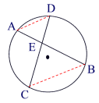



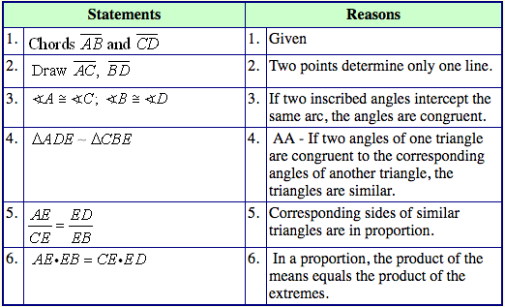

Theorem 2:

If two secant segments are drawn to a circle from the same external point, the product of the length of one secant segment and its external part is equal to the product of the length of the other secant segment and its external part.

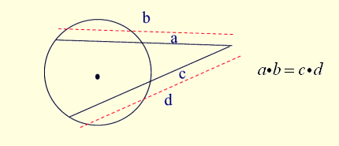

Secant-Secant Rule: (whole secant)×(external part) =(whole secant)×(external part)

Theorem 3:

If a secant segment and tangent segment are drawn to a circle from the same external point, the product of the length of the secant segment and its external part equals the square of the length of the tangent segment.

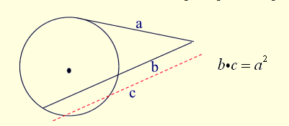

Secant-Tangent Rule:(whole secant)×(external part) =(tangent)2

Theorems Relating to Tangent to a Circle in Solving Problems

Apply theorems relating to tangent to a circle in solving problems

Example 7

Two common tangents to a circle form a minor arc with a central angle of 140 degrees. Find the angle formed between the tangents.

Solution

Two tangents and two radii form a figure with 360°. If y is the angle formed between the tangents then y + 2(90) + 140° = 360°

y = 40°.

The angle formed between tangents is 40 degrees.

TOPIC 7: THE EARTH AS THE SPHERE

Features and Location of Places

The Equator, Great Circle, Small Circles, Meridian, Latitudes and Longitudes

Describe the equator, great circle, small circles, meridian, latitudes and longitudes

Definition of latitude and longitude

The Earth is not a perfect sphere, as it is slightly flatter at the north and south poles than at the equator. But for most purposes we assume that it is a sphere.

The position of any point on earth is located by circles round the earth, as follows:

The earth rotates about its axis, which stretches from the north to the South Pole.

Circles round the Earth perpendicular to the axis are circles of Latitude and Circles round the Earth which go through the poles are circles of Longitude or meridians.

Consider the following diagram

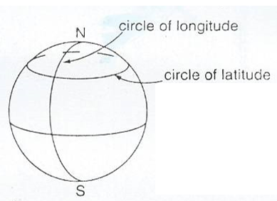

Normally Latitude is defined relative to the equator, which is the circle of latitude round the middle of the Earth while Longitude is defined relative to the circle of longitude which passes through Greenwich in London (Greenwich meridian).

The latitude of a position tells us how far north or south of the equator it is while the longitude of a position shows us how far east or west of the Greenwich meridian it is.

Latitude; If we draw a line from the centre of the Earth to any position P , then the angle between this line and the plane of the equator is the latitude of P.

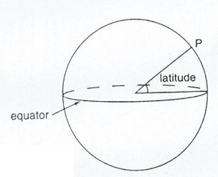

Longitude: This is the angle between the plane through the circle of any Longitude P and the plane of the Greenwich meridian .

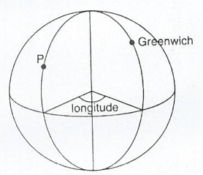

Latitude can be either North or South of the equator while Longitude can be either East or West of Greenwich.

When locating the latitude and longitude of a place we write the latitude first then longitude.

Example 1

Dar es Salaam has latitude 7°S (i.e. 7° south of the equator) and longitude 39°E (i.e. 39° east of the Greenwich meridian). So Dar es Salaam is at (7°S, 39°E).

NB; Greenwich itself has latitude 51°N ( i.e. 51° north of the equator)and longitude 0° (by definition). Johannesburg has latitude 26°S (i.e. 26 south of the equator) and longitude 28°E(i.e. 28°east of the Greenwich meridian), therefore Johannesburg is at (26°S, 28°E).The north pole has latitude 90°S but its longitude is not defined. ( Every circle of longitude goes through the north pole).The south pole has latitude 90°s. Its longitude is not defined. So all points on the equator (such as Nanyuki in Kenya) have latitude 0°

Ranges; Latitude varies between 90°S (at the south pole) to 90°N (at the north pole).

Ranges; Latitude varies between 90°S (at the south pole) to 90°N (at the north pole). Longitude varies between 180°E and 180°W. These are the longitudes on the opposite side of the Earth from Greenwich.

GREAT AND SMALL CIRCLES: There is an essential difference between latitude and longitude. Circles of longitude all have equal circumference. Circles of latitude get smaller as they approach the poles. The centre of a circle of longitude is at the centre of the earth. They are called great circles. For circles of latitude, only the equator itself is a great circle. Circles of latitude are called small circles.

Example 2

Find the latitudes and longitudes of A and B on the diagram below;

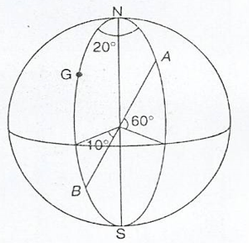

Solution;

The point A is 60° above equator, and 20° east of Greenwich.

So the point A is at (60°N, 20°E)

The point B is 10° below the equator, and on the Greenwich meridian.

So the point B is at (10°S, 0°).

Exercise 1

1. Write down the latitude and longitude of the places shown on figures below:

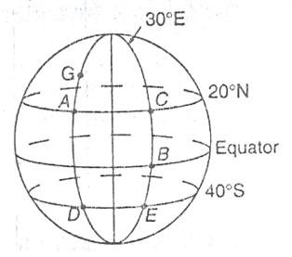

2. Copy the diagram show on the figure above and mark these points:

(10°N, 30°E)

(20°N, 20°W)

(0°, 20°W)

3. Obtain a globe, and on it identify the following places.

(40°S, 30°E)

(50°S,20°W)

(10°N,40°W)

(40°N, 30°E)

(80°N,10°E)

(0°,0°)

Difference between angles of latitude or longitude

Suppose two places have the same longitude but different latitudes. Then they are north and south of each other.

In finding the difference between the latitudes take account of whether they are on the same side of the equator or not.

If both points are south of the equator subtract the latitudes

If both points are the north of the equator subtract the latitudes

If one point is south of the equator and the other north then add the latitudes

Similarly, suppose two places have the same latitudes but different longitudes:

If both points are east of Greenwich subtract the Longitudes

If both points are west of Greenwich subtract the Longitudes

If one point is east of Greenwich and the other west then add the longitudes

Suppose places A and B are on the same longitude, then the difference in latitude is theangle subtended by AB at the centre of the earth.

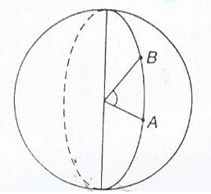

Suppose places A and B are on the same latitude.

Then the difference in longitude is the angle subtended by AB on the earth's axis.

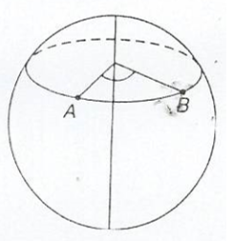

Locating a Place on the Earth’s Surface

Locate a place on the Earth’s surface

Example 3

Three places on longitude 30°E are Alexandria (in Egypt) at (31°N, 30°E), Kigali (in Rwanda) at (2°S, 30°) and Pietermaritzburg (in South Africa) at (30°S, 30°E).

Find the difference in latitude between

Kigali and Pietermaritzburg

Kigali and Alexandria

Solution

(a)Both Towns are south of the equator. So subtract the latitudes. 30 – 2 = 28

Therefore the difference is 280

(b) Kigali is south of the equator, and Alexandria is north, so add the latitudes

31 + 2 = 33

The difference is 330

Example 4

A plane starts at Chileka airport (in Malawi) which is at (16°S, 35°E). It flies west for 50°. What is its new latitude and longitude?

Solution

Since it flies west, then subtract 35° from 50°. This gives 15°

The new longitude is now west of Greenwich, hence the plane is at (16°S, 15°W).

Exercise 2

1. In the diagram shown in the following figure find,

The difference in longitude between A and B

The difference in longitude between D and E

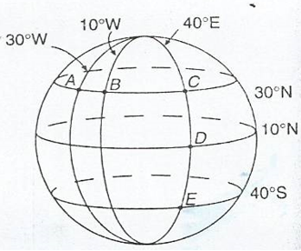

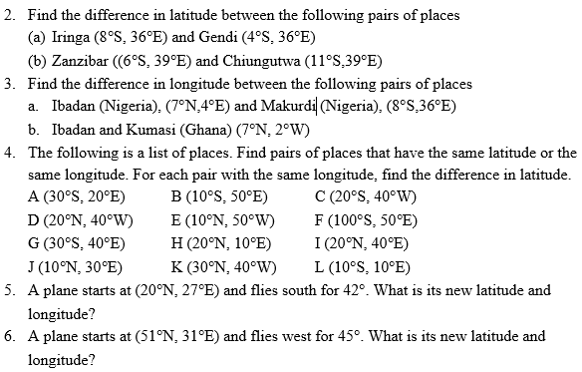

Distances along Great Circles

Distances along Great Circles

Calculate distances along great circles

Take two places X and Y on the same line of longitude, i.e. one place is due north of the other. Suppose X is due north of Y. When travelling north from Y to X, you travel along part of a circle of longitude that is you travel along an arc of the circle.

The diagram below shows two points A and B on the same circle of longitude.

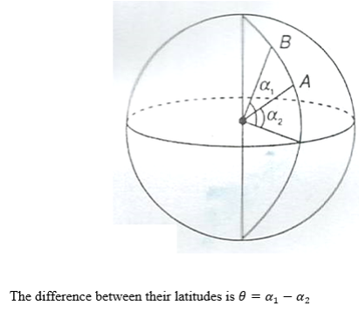

In the figure above, the sector containing the arc AB subtending∅, is shown.

Recall the formula for the length of arc.

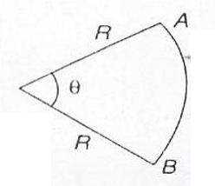

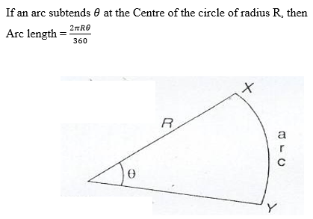

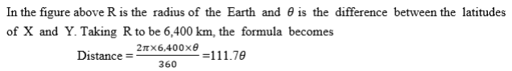

NB: Remember, to find the difference in latitudes, take account of whether the places are north or south of the equator. If they are all found in south or north, then subtract the latitudes. If one is south and the other North then add the latitudes.

Nautical miles

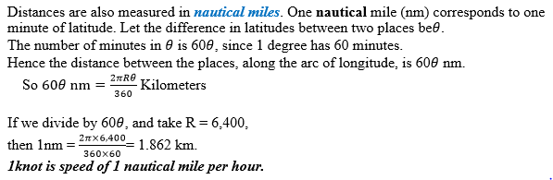

Navigation Related Problems

Solve navigation related problems

Example 5

Find the distance between Alexandria (31°N, 30°E) and Kigali (2°S, 30°E)

Solution

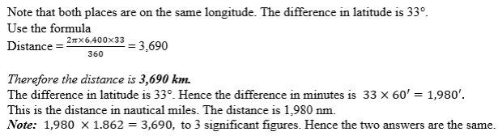

Example 6

A plane starts at (200S, 300E), and flies north for 4000 km. Find its new latitude and longitude.

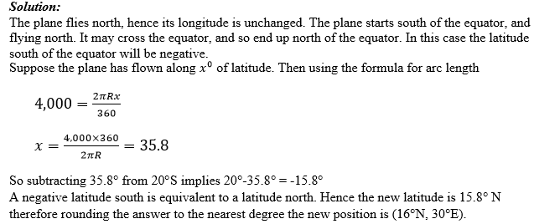

Example 7

A plane flies north from (10°S, 30°E) to ((27°N, 30°E) taking a time of 3 hours.

Find its speed, giving your answer I both knots and kilometers per hour.

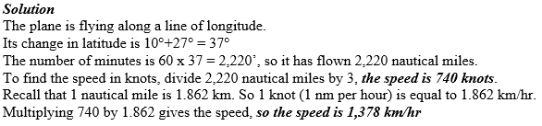

Exercise 3

Consider the following Questions.

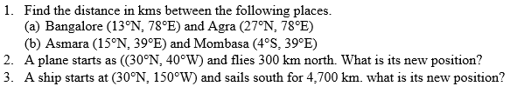

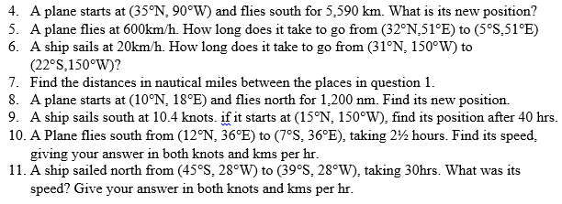

Distances along Small Circles

Distance along Small Circles

Calculate distance along small circles

Suppose P and Q are places west or east of each other, i.e they lie on the same circle of latitude. Then when you travel due east or west from P to Q you travel along an arc of the circle of latitude.

The situation here is slightly different from that of the previous section. While circles of longitude all have the same length, circles of latitude get smaller as they get nearer the poles.

Consider the circle of latitude 50°S. Let its radius be r km.

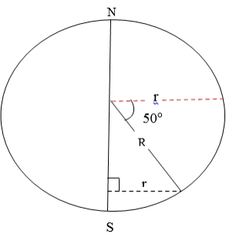

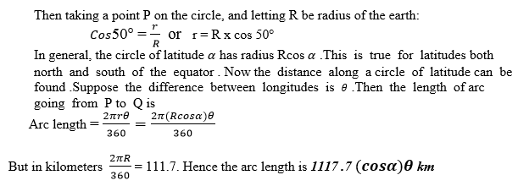

Nautical miles



Example 8

Find the distance in km and nm along a circle of latitude between (20°N, 30°E) and (20°N, 40°W).

Solution:

Both places are on latitude 20°N. The difference in longitude is 70°. Use the formula for distance.

Distance = 111.7 cos20° x 70°. Hence the distance in nautical miles is 60 x 70 x cos20°

The distance is 3,950 nm.

Example 9

A ship starts at (40°S, 30°W) and sails due west for 1,000 km. Find its new latitude and longitude.

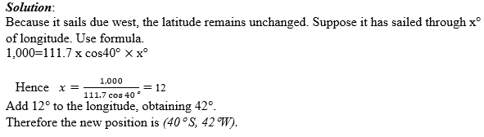

Example 10

A ship sails west from (20°S, 15°E) to (20°S, 23°E), taking 37 hours. Find speed, in knots and in kms per hr.

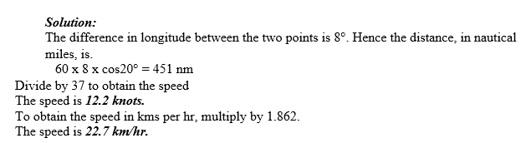

Exercise 4

Consider the following Questions.

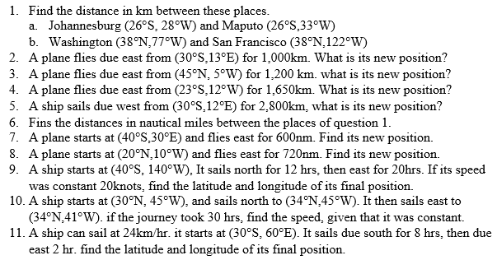

Navigation

Suppose a ship is sailing in a sea current, or that a plane is flying in a wind. Then the course set the ship or plane is not the direction that it will move in. the actual direction and speed can be found either by scale or by the use of Pythagoras’s theorem and trigonometry.

Draw the line representing the motion of the ship relative to the water. At the end of this line draw a line representing the current. Draw the third side of the triangle. This side, shown with a double – headed arrow, is the actual course of ship.

Example 11

A ship sets course due east. In still water the ship can sail at 15km/hr. There is a current following due south of 4kkm/hr. use a scale drawing to find.

The speed of the ship

The bearing of the sip.

Solution:

In one hour the ship sails 15km east relative to the water. Draw a horizontal line of length 15cm. In one hour the current pulls the ship 4km south. At the end of the horizontal line, draw a vertical line of length 4cm.

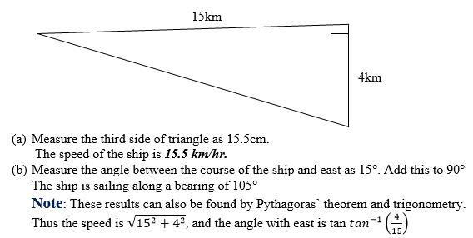

Example 12

The ship of example 10 needs to travel due east. Calculate the following.

What course should be set?

How long will the ship take to cover 120km?

Solution

The ship needs to set a course slightly north of east, consider the following diagram.

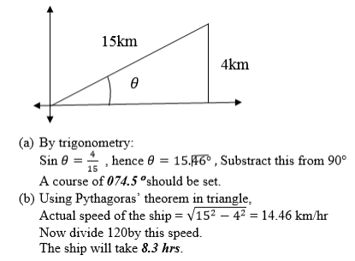

Note: With no current, the journey would take 8hrs. The journey takes slightly longer when there is a current.Suppose a ship or a plane does not directly reach a position. We can still find how close the ship or plane is to the position.

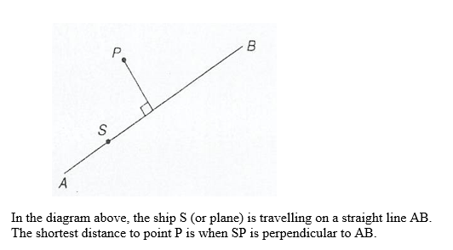

Example 13

A small island is 200km away on a bearing of 075°. A ship sails on a bearing of 070°.Find the closest that the ship is to the island.

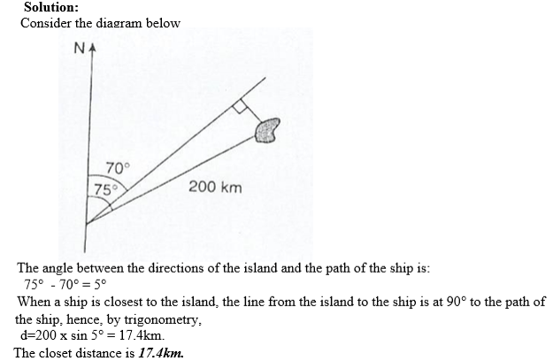

Exercise 5

1. Find the difference in longitude between Cape Town (34°S, 18°E) and Buenos Aires (34°S, 58°W)

2. A ship startsat (15°N, 30°W) and sails south for 2,500km. Where does it end up?

3. Find thedistance in km along circle of latitude between cape Town and Buenos aires (see question 2)

4. A plane starts at (37°S, 23°W) and flies east for 1,500 km. where does it end up?

5. Find thedistance in nau

**TOPIC 8: ACCOUNTS**

**Double Entry**

The Meaning of Double Entry

Explain the meaning of double entry

Businesses need to keep records of their transactions. The process of keeping record is called **bookkeeping**. The simplest form of bookkeeping is single entry. Every transaction is recorded once. This is unreliable because:

* If an arithmetic mistake is made, it is very difficult to find and correct it
* If a transaction is omitted, it is difficult to find it

Now, a more reliable method of bookkeeping is ***double entry***.

Different Types of Ledger

Explain different types of ledger

Businesses record their accounts in books called ledgers. A ledger is a main book that contains various accounts.

There are three main ledgers:

* The sales ledger
* The purchases ledger
* The general ledger

-The ***sales ledger:*** Is the ledger that records the accounts of debtors. The ledger is also known as the ***debtors’ ledger.*** A ***debtor*** is a person who owes money to the business, that is a person to whom the business sold goods on credit. So when the business has a new customer, it will open an account in the sales ledger for that customer.

***-The purchases ledger:*** Is the ledger that records the accounts of creditors. This ledger is also known as the ***creditors’ ledger.*** A ***creditor*** is a person whom the business owes money, that is a person from whom the business bought goods on credit. When the business has a new supplier, it will open an account in the purchases ledger for that supplier.

***-The general ledger***: Is a ledger that records all accounts other than debtors’ and creditors’ accountants. Examples of accounts recorded all accounts other than debtors’ and creditors’ accounts are fixed assets and expense.

-Double entry: Is a bookkeeping system whereby every transaction is recorded twice in the ledger. It is recorded on the left as **debit (DR),** and on the right as **credit (CR).** Every transaction involves the giving and receiving of a benefit.

A Ledger

Construct a ledger

Suppose that a company takes 50,000/- from the bank to pay wages.

* The bank account gives the benefit, and so is credited 50,000/-
* The wages account receives the benefit, and so is debited 50,000/-

Suppose the company buys assets worth 100,000/- from ABC Limited.

* ABC Limited has given the benefit, and so is credited 100,000/-
* The fixed assets account has received the benefit, and so is debited 100,000/-

When transactions are written in a ledger, they are said to be posted to the ledger.

Posting Entries in the Ledger

Post entries in the ledger

Example 1

The transactions shown in the table below belong to XYZ Traders; Post them to the relevant ledgers.

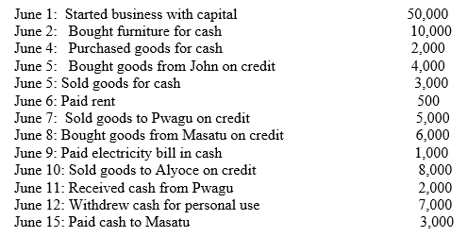

***Solution***

In the first transaction, money is taken from the capital account and placed cash account. Hence the capital account is credited and he cash account is debited. In the’ Particular’ column, write the other account involved in the transaction.

In the second transaction, furniture is bought for cash. So the cash account is credited and the furniture account is debited.

Pwagu and Aloyce are customers, so they each have accounts in the sales ledger, John and Masatu are suppliers, so they each have accounts in the purchases ledger.

Other items are capital, cash, furniture, purchases, sales, rent, electricity and drawing. They all have accounts in the general ledger.

GENERAL LEDGER

Capital account

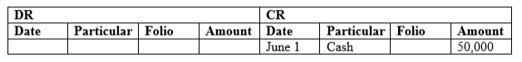

Cash account

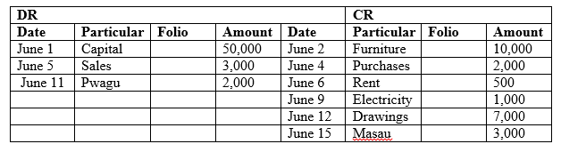

Furniture account

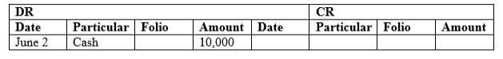

Purchases account

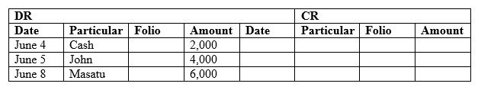

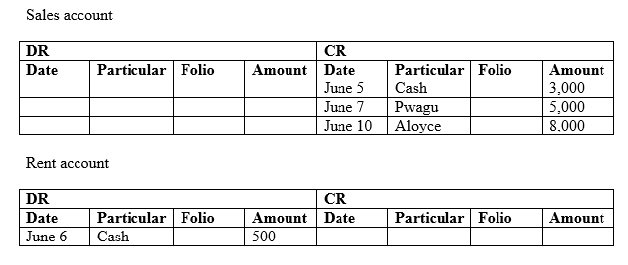

Electricity account

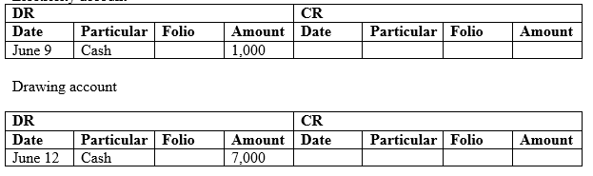

PURCHASES LEDGER

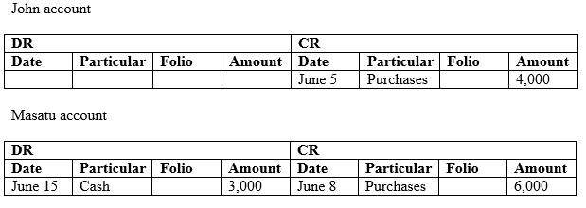

**Sales ledger**

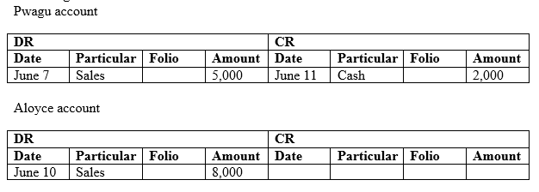

***Note:*** Check that for each transaction there are two equal entries, one for debit and one for credit, for instance:

June 11: Received cash from Pwagu, 2,000

-Pwagu’s account is credited 2,000

-The cash account is debited 2,000

This is what is meant by double entry.

Closing the Simple Accounts

Close the simple accounts

Closing the accounts is the process of balancing the accounts. This involves determining the totals of the debits and credits, and finding the difference between the two sides. The difference is ***the balancing figure***, which is placed in the side that is less. This makes the two sides equal.

Example 2

Consider the following account from Example 1. Close this account.

Cash account

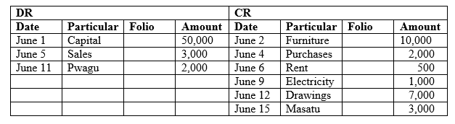

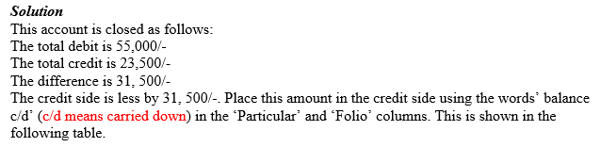

Cash account:

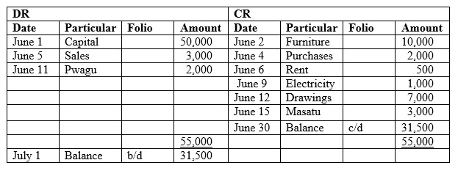

The balance c/d shows the amount that stands on the account on the closing date. It appears as balance b/d (b/d means brought down) on the opening date of the next trading period, on the other side of the ledger.

Exercise 1

1. What is a ledger? Give an explanation of three ledgers you know, with an example of accounts kept in each ledger.

2. For each of the following transactions, name the ledger it would be posted to, and whether this would be as credit or debit.

1. a lorry bought for cash
2. goods sold to Mr. Sabaya for cash

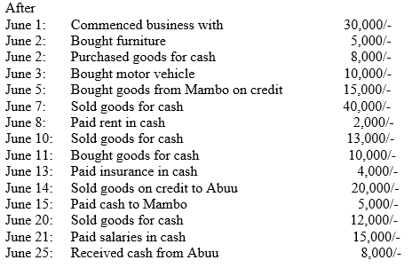

**Trial Balance**

The Concept of Trial Balance

Explain the concept of trial balance

***Trial balance*** is a statement which shows the balances of accounts extracted from the ledger. At the end of each trading period, the accounts in the ledger are closed, that is the balance of each account is determined. These balances are then shown in the trial balance.

Below is the format of a trial balance.

TRIAL BALANCE as at 30 June 2005

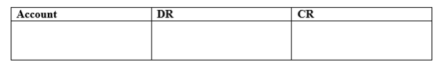

Accounts with debit balances are posted in the DR column and those with credit balances in the CR column.

***Functions of trial balance***

The trial balance serves the following two major roles:

-It checks the arithmetical accuracy of the ledger. The double entry system requires posting equal amounts to debits and credits. Therefore the trial balance is expected to balance if the arithmetic was correct. If there is a difference in the totals of the debit and credit columns of the trial balance, then some errors were made.

-It simplifies the preparation of the final accounts. The trial balance contains all the accounts extracted from the ledgers. This makes it easy to post the accounts to the final accounts.

Construction of Trial Balance

Construct trial balance

Look again at Example 1 of XYZ Traders. The accounts, after being closed, appear as follows:

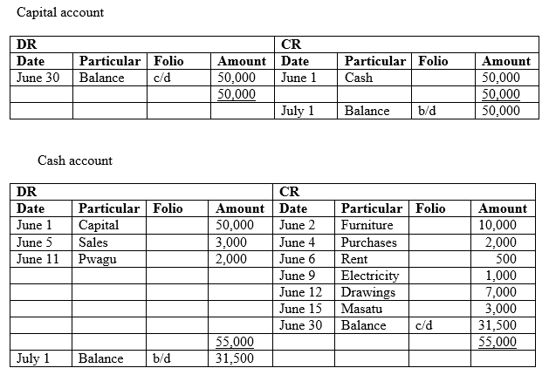

Purchases account

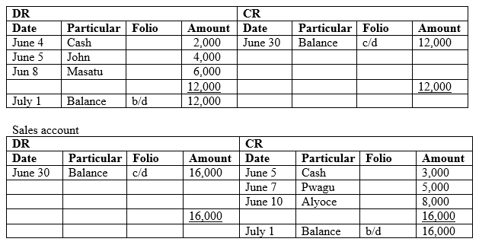

Rent account

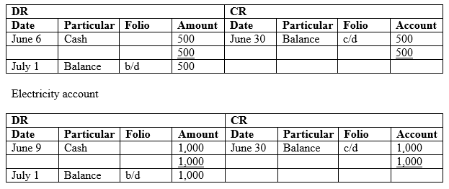

**And other accounts closing.**

***NB.*** The balance b/d determines whether the account has a debit or credit balance.

Example 3

Construct the trial balance for XYZ Traders of Example 1.

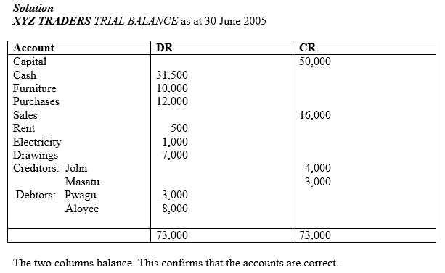

Exercise 2

1. Why is trial balance referred to as statement of arithmetical accuracy?

2. Trial balance is statement and not part of double entry. explain why?

3. The following balances were extracted from the ledgers of Doka traders on 30 June 2005.

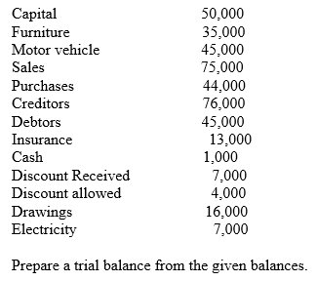

Debit Balances and Credit Balances

Post debit balances and credit balances

**DEBIT BALANCES:**

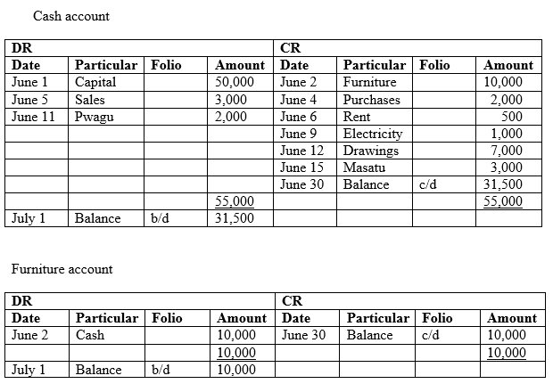

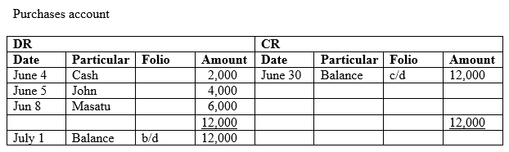

**CREDIT BALANCES:**

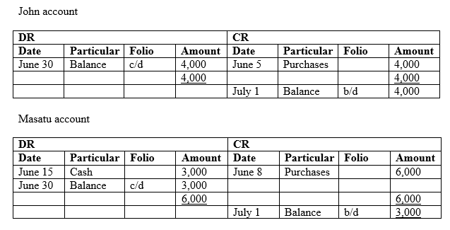

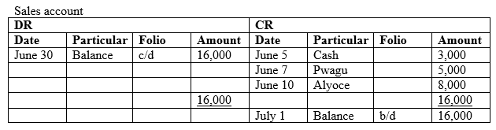

Checking the Balances

Check the balances

Activity 1

Check the balances

**Trading Profit and Loss**

Gross Profit/Loss using Trading Account

Ascertain gross profit/loss using trading account

The trading and profit and loss A/C is an account that is composed of two accounts, the trading A/C, and the profit and loss A/C.

***The trading A/C*** is used to determine the gross profit of the goods sold:

Gross profit = sales – cost of goods sold

***The profit and loss account (A/C)*** is the part of the account that determines the net profit loss:

Net profit = gross profit – expenses

Net loss = expenses – gross profit

***-In the profit and loss A/C, the gross profit and other revenues are credited to the account while the operating expenses are debited.***

***-We have net profit if the credit is greater than the debit and net loss if the debit is greater than the credit.***

Example 4

The following is the trial balance of FMHN Trading Co. as at 31 December 2004. Prepare the trading and profit and loss accounts for the year 2004.

***FMHN TRADING CO.***

***TRIAL BALANCE*** as at 31 December 2004

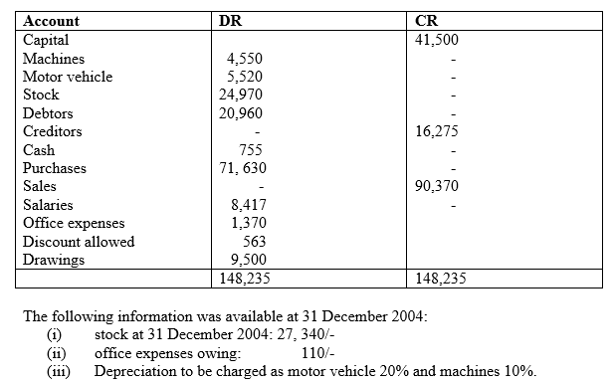

**Solution**

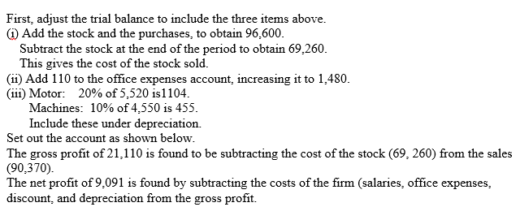

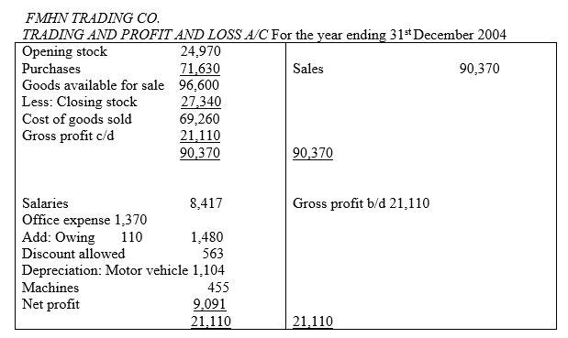

Net Profit/Loss Account

Ascertain net profit/loss account

When net loss is recorded, the profit and loss A/C appears as shown in the following example.

PROFIT AND LOSS A/C

For the year ending ……………………

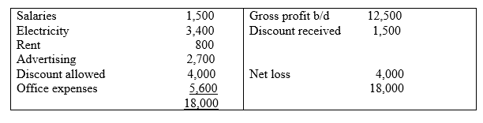

Exercise 3

1. Explain the function of trading A/C.

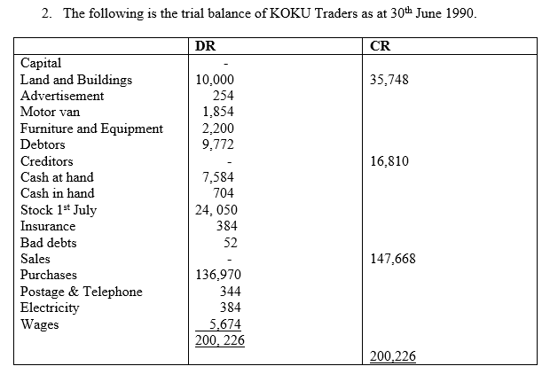

**Balance Sheet**

A Balance Sheet

Construct a balance sheet

A balance sheet is a statement which shows the financial position of a business at a particular date.

It shows the ***assets*** on one side and ***liabilities*** on the other.

Assets are divided into two: **fixed assets** and **current assets.**

***-Fixed assets*** are possessions of the business that assist the business in its operations, and benefit the business for more than one accounting period.

***-Current assets*** are assets of the business used in generating income during the accounting period.

***Liabilities*** are also grouped into two: ***long term liabilities***, which are payable in more than one accounting period and current liabilities, which are payable within the accounting period.

The following is the format of balance sheet showing the common items of the balance sheet.

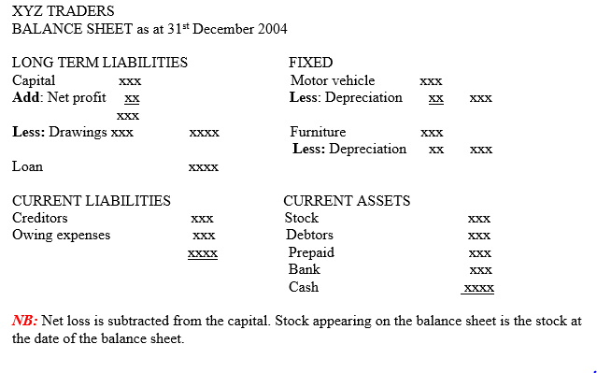

Posting Entries in Balance Sheets

Post entries in balance sheets

Example 5

Considering FMHN Trading Co. from above example, the balance sheet will be as

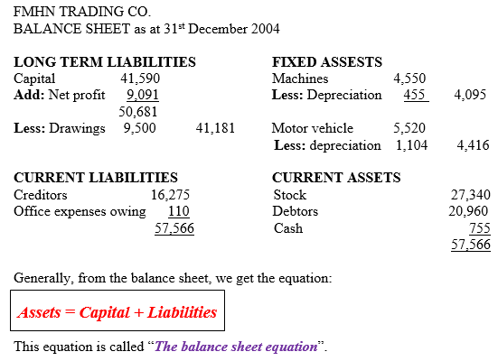

Interpreting Information from the Balance Sheet

Interpret information from the balance sheet

From the balance sheet, useful information concerning the business can be extracted. The interpretation then depends on the use of the information.

The following are some of the useful information provided by the balance sheet.

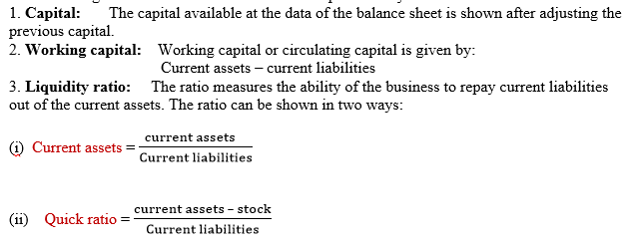

The quick ratio measures the ability of the business to pay current liabilities out of current assets excluding stock which is considered less liquid.

From the balance sheet of FMHN Trading Co. we can find the following.

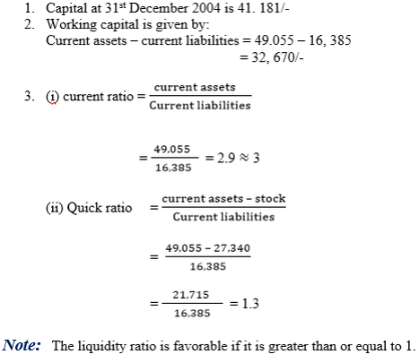

Exercise 4

1. Prepare the balance sheet for the balances given in the table below.

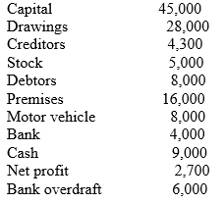

2. From the balance sheet constructed in question 2, determine the following.

1. Working capital
2. Quick ratio
3. Current ratio

***Summary***

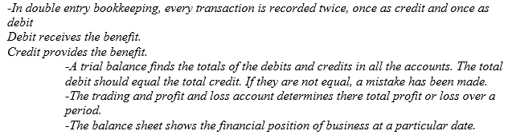

Exercise 5

1. Explainan advantage of double entry bookkeeping over single entry bookkeeping.

2. Givethree accounts that would be kept in the general ledger.

3. Define the quick liquidity ratio.

4. Xis acustomer of company PQR. Below are the transaction made by X over a month.

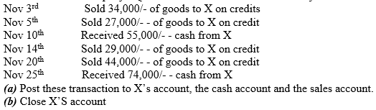

5. The following table shows the closing balances of company PQR of question 4.

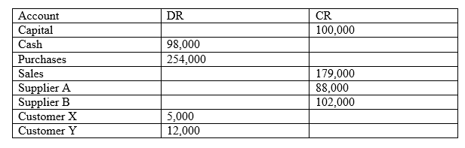

6. Below is a trial balance for Nyati Ltd. The closing stock was 1, 750,000/-, and the van was depreciated at 25%. Set up the trading and profit and loss account.

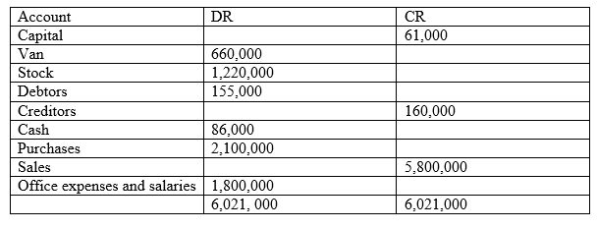

7. Complete the balance sheet below for Nyati Ltd. of question 6.

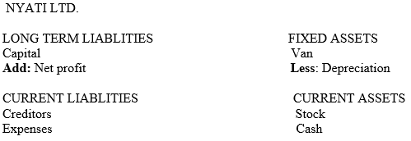

8. Use the balance sheet constructed in question 7 to find the following.

1. capital
2. working capital
3. current liquidity
4. quick liquidity rate